FINITE ELEMENT ANALYSIS (17ME61)

BGS Institute of Technology

Vision
BGSIT is committed to the cause of creating tomorrow’s engineers by providing quality education inculcating ethical values.
Mission
M1: Imparting quality technical education by nurturing a conducive learning environment.
M2: Offering professional training to meet industry requirements.
M3: Providing education with a moral - cultural base and spiritual touch.

DEPARTMENT OFMECHANICAL ENGINEERING

VISION:
Producing competent and sustainable Mechanical Engineers through Excellence, Innovations and Ethics.
MISSION:
M1: Offering quality Education by competent faculty.
M2: Providing adequate infrastructure and learning ambience.
M3: Developing inclination towards higher education, research, entrepreneurship and professional ethics.
M4: Promoting interaction with industries.
Program Educational Objectives (PEOs)
PEO-1: Graduate will be pursuing successful career & higher education.
PEO-2: Graduates will be able to Design, Analyze, Fabricate & Manage Applications of Mechanical Engineering.
PEO-3: Graduates will display Professional Ethics to work in a team & lead the team by effectively Communicating the ideas.
PEO-4: Graduates will practice Life long learning
Program Specific Outcomes (PSOs)
PSO-1: Ability to acquire competencies in Designing, Analyzing and Evaluating the Mechanical Components.
PSO-2: Ability to work Professionally by applying Manufacturing and Management practices.

PROGRAM OUTCOMES (PO’S)

The Mechanical engineering program students will attain:

PO1. Engineering knowledge: Apply the knowledge of mathematics, science, engineering fundamentals, and an engineering specialization to the solution of complex engineering problems

PO2. Problem analysis: Identify, formulate, research literature, and analyze complex engineering problems reaching substantiated conclusions using first principles of mathematics, natural sciences, and engineering sciences

PO3. Design/development of solutions: Design solutions for complex engineering problems and design system components or processes that meet the specified needs with appropriate consideration for the public health and safety, and the cultural, societal, and environmental considerations

PO4. Conduct investigations of complex problems: Use research-based knowledge and research methods including design of experiments, analysis and interpretation of data, and synthesis of the information to provide valid conclusions

PO5. Modern tool usage: Create, select, and apply appropriate techniques, resources, and modern engineering and IT tools including prediction and modeling to complex engineering activities with an understanding of the limitations

PO6. The engineer and society: Apply reasoning informed by the contextual knowledge to assess societal, health, safety, legal and cultural issues and the consequent responsibilities relevant to the professional engineering practice

PO7. Environment and sustainability: Understand the impact of the professional engineering solutions in societal and environmental contexts, and demonstrate the knowledge of, and need for sustainable development

PO8. Ethics: Apply ethical principles and commit to professional ethics and responsibilities and norms of the engineering practice
PO9. Individual and team work: Function effectively as an individual, and as a member or leader in diverse teams, and in multidisciplinary settings

PO10. Communication: Communicate effectively on complex engineering activities with the engineering community and with society at large, such as, being able to comprehend and write effective reports and design documentation, make effective presentations, and give and receive clear instructions

PO11. Project management and finance: Demonstrate knowledge and understanding of the
engineering and management principles and apply these to one’s own work, as a member and leader in a team, to manage projects and in multidisciplinary environments

PO12. Life-long learning: Recognize the need for, and have the preparation and ability to engage in independent and life-long learning in the broadest context of technological change

FINITE ELEMENT ANALYSIS Course Code : 17ME61

Module 1
Introduction to Finite Element Method : General description of the finite element method. Engineering applications of finite element method. Boundary conditions: homogeneous and non homogeneous for structural, heat transfer and fluid flow problems. Potential energy method, Rayleigh Ritz method, Galerkin’s method, Displacement method of finite element formulation. Convergence criteria, Discretization process, Types of elements: 1D, 2D and 3D, Node numbering, Location of nodes. Strain displacement relations, Stress strain relations, Plain stress and Plain strain conditions, temperature effects
Interpolation models :Simplex, complex and multiplex elements, Linear interpolation polynomials in terms of global coordinates 1D, 2D, 3D Simplex Elements

Module 2
One-Dimensional Elements-Analysis of Bars and Trusses : Linear interpolation polynomials in terms of local coordinate’s for1D, 2Delements. Higher order interpolation functions for 1D quadratic and cubic elements in natural coordinates, Constant strain triangle, Four-Nodded Tetrahedral Element (TET 4), Eight-Nodded Hexahedral Element (HEXA8), 2D iso- parametric element, Lagrange interpolation functions, Numerical integration: Gaussian quadrature
one point, two point formulae, 2D integrals. Fore terms: Body force, traction force and point loads,
Numerical Problems: Solution for displacement, stress and strain in 1D straight bars, stepped bars and tapered bars using elimination approach\n and penalty approach, Analysis of trusses

Module 3
Beams and Shafts : Boundary conditions, Load vector, Hermite shape functions, Beam stiffness matrix based on Euler- Bernoulli beam theory, Examples on cantilever beams, propped cantilever beams, Numerical problems on simply supported, fixed straight and stepped beams using\ndirect stiffness method with concentrated and uniformly distributed load
Torsion of Shafts : Finite element formulation of shafts, determination of stress and twists in circular shafts

Module 4
Heat Transfer : Basic equations of heat transfer: Energy balance equation, Rate equation: conduction, convection, radiation, energy generated in solid, energy stored in solid, 1D finite element formulation using vibrational method, Problems with temperature gradient and heat fluxes, heat transfer in composite sections, straight fins

Module 5
Axi-symmetric Solid Elements: Derivation of stiffness matrix of axisymmetric bodies with triangular elements, Numerical solution of axisymmetric triangular element(s) subjected to surface forces, point loads, angular velocity, pressure vessels.
Dynamic Considerations : Formulation for point mass and distributed masses, Consistent element mass matrix of one dimensional bar element, truss element, axisymmetric triangular element, quadrilateral element, beam element. Lumped mass matrix of bar element, truss element, Evaluation of Eigen values and Eigen vectors, Applications to bars, stepped bars, and beams

6 . Course Information
6 . 1 . 2 Text Books and Reference Books

TEXT BOOKS :
- . Logan, D. L., A first course in the finite element method,6th Edition, Cengage Learning, 2016.
- . Rao, S. S., Finite element method in engineering, 5th Edition, Pergaman Int. Library of Science, 2010. 3 . Chandrupatla T. R., Finite Elements in engineering, 2nd Edition, PHI, 2013.

REFERENCE BOOKS :
- . J.N.Reddy, “Finite Element Method”- McGraw -Hill International Edition. Bathe K. J. Finite Elements Procedures, PHI.
- . Cook R. D., et al. “Concepts and Application of Finite Elements Analysis”- 4th Edition, Wiley & Sons, 2003.

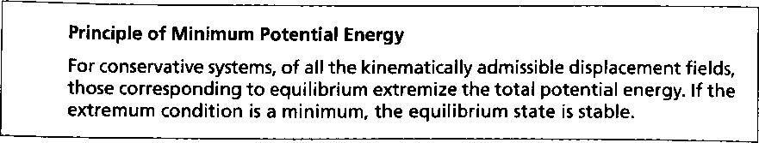
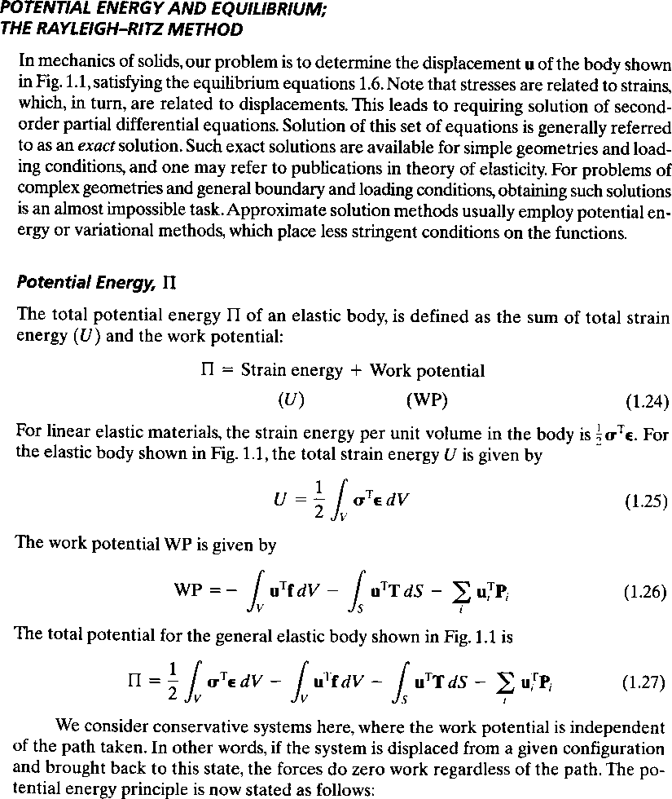

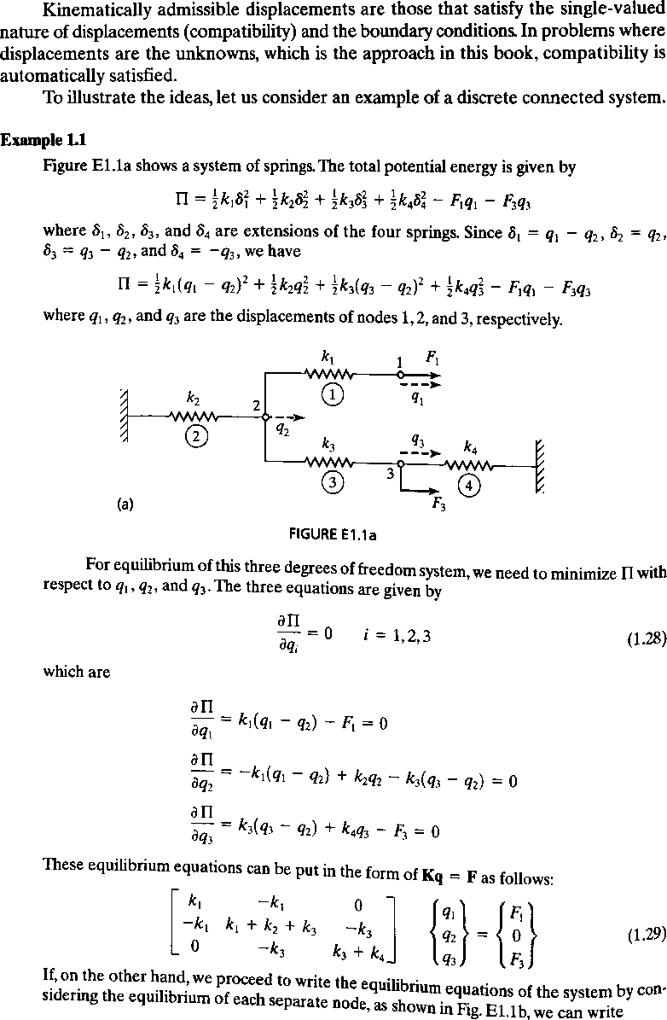

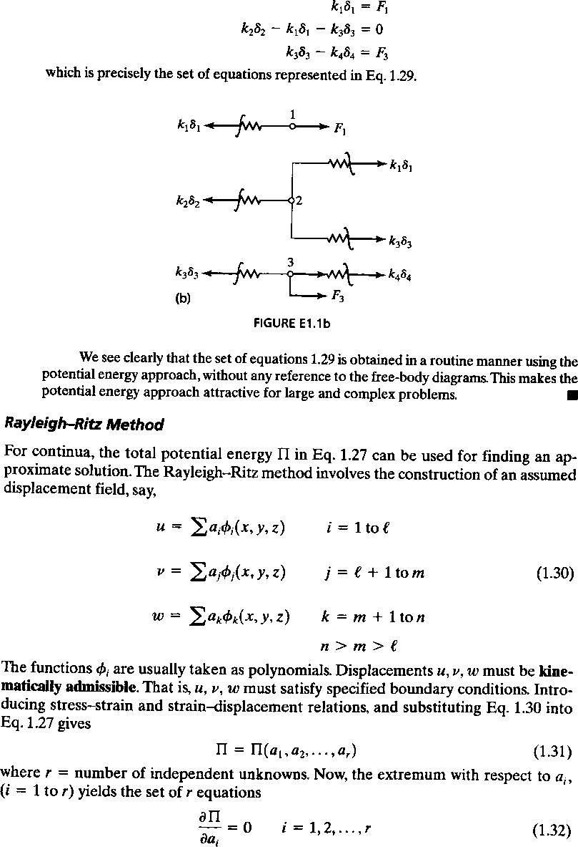

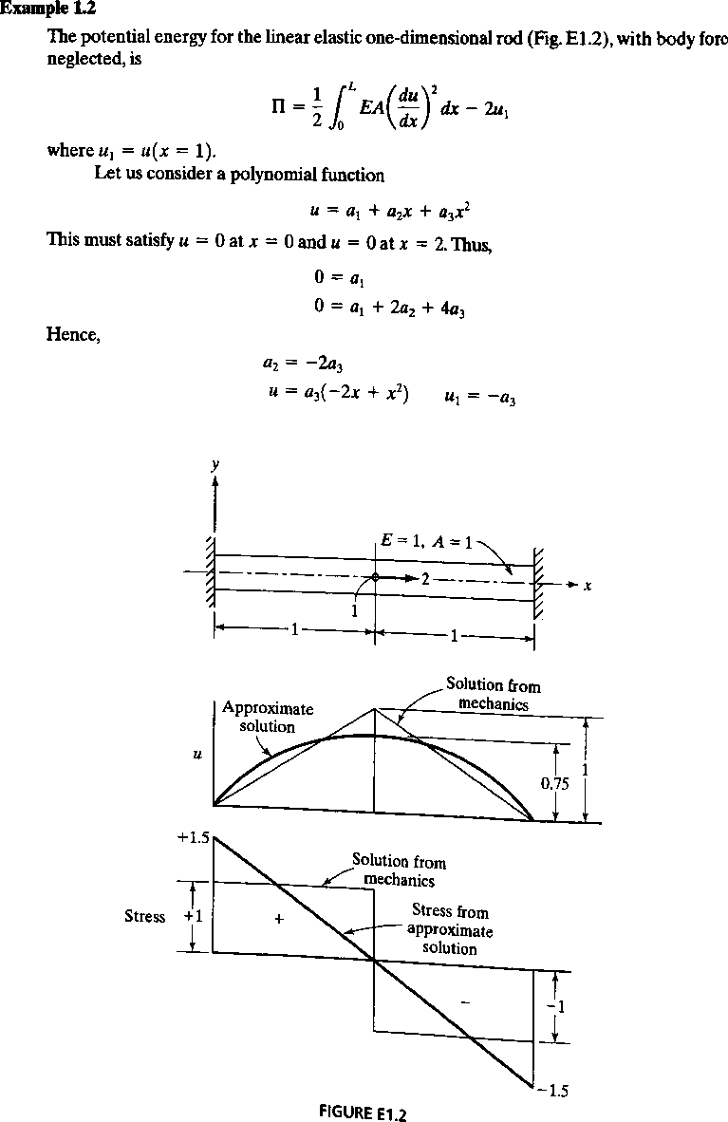

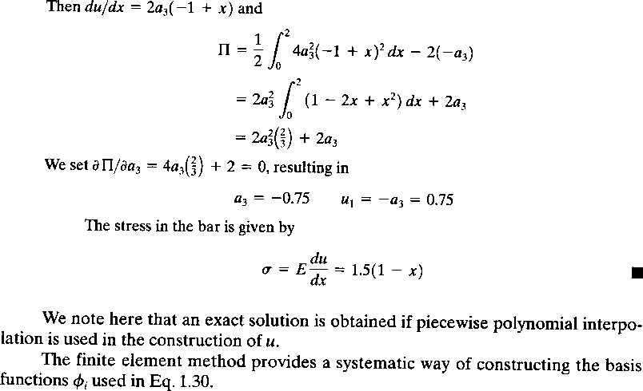
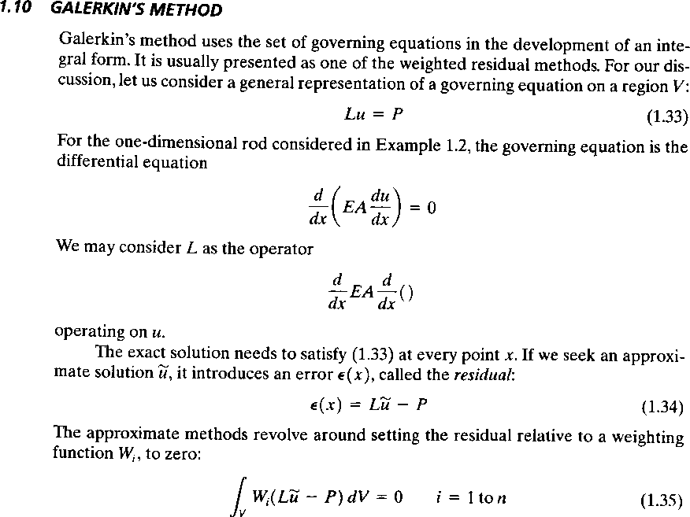

Introduction to Theory of Elasticity
Objectives
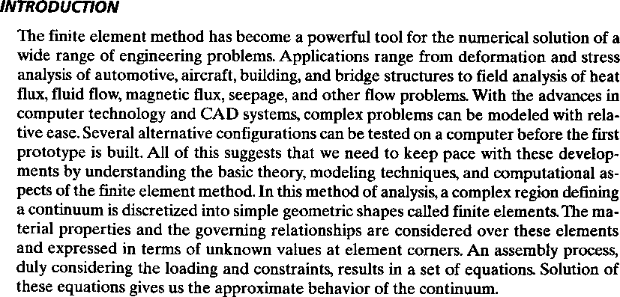
To introduce to the concept of elasticity, Finite Element Method Steps, advantages, disadvantages and application of FEM.

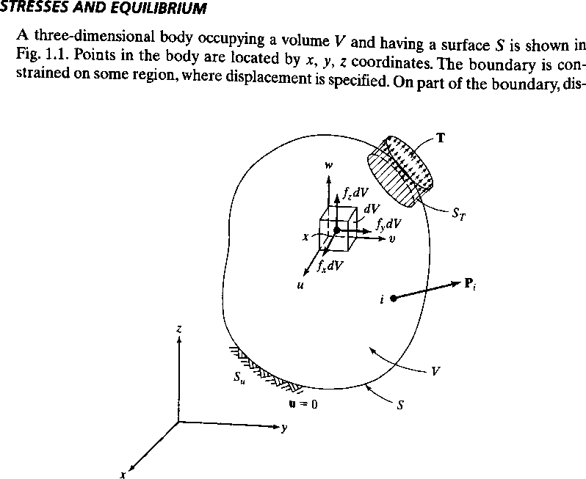
3D body

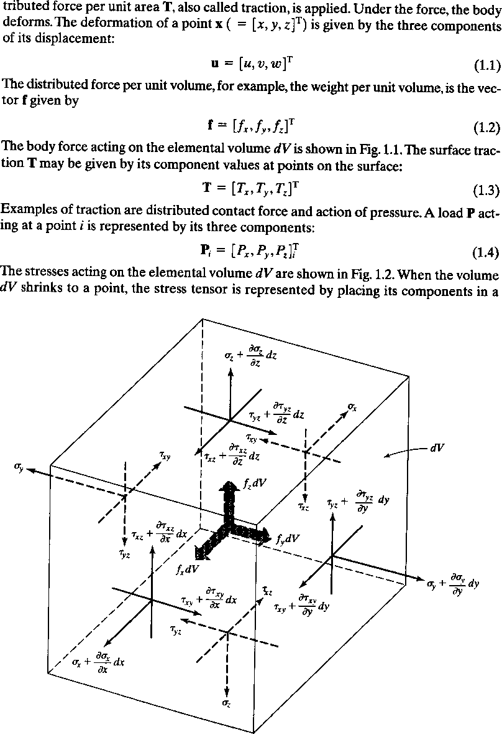

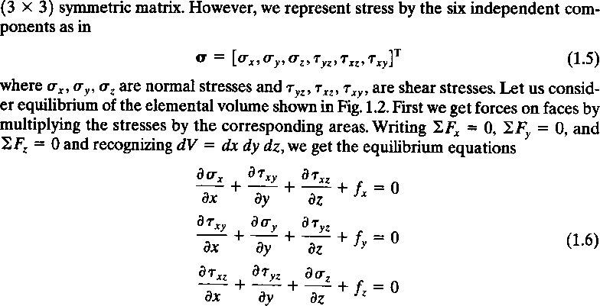

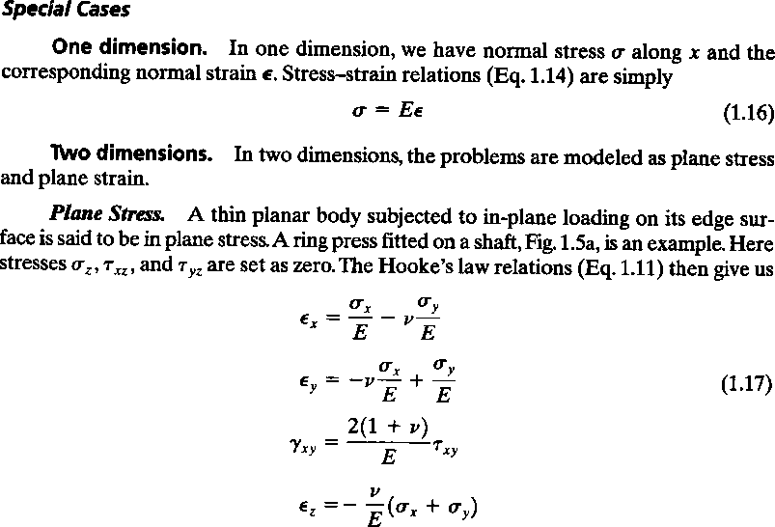

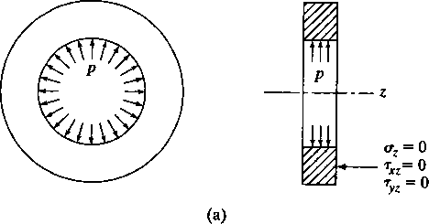

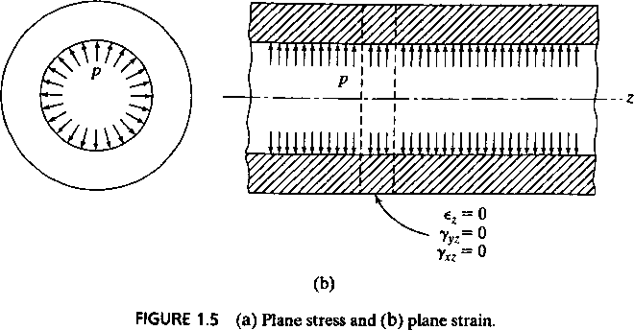

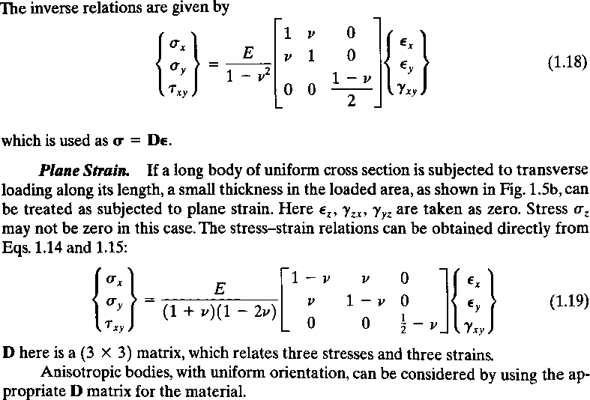

Outcomes
Brief idea on elasticity concepts and introductory concepts of FEM

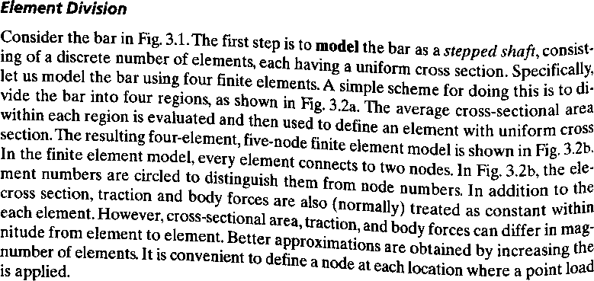

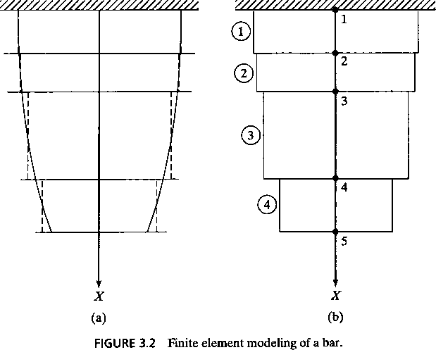

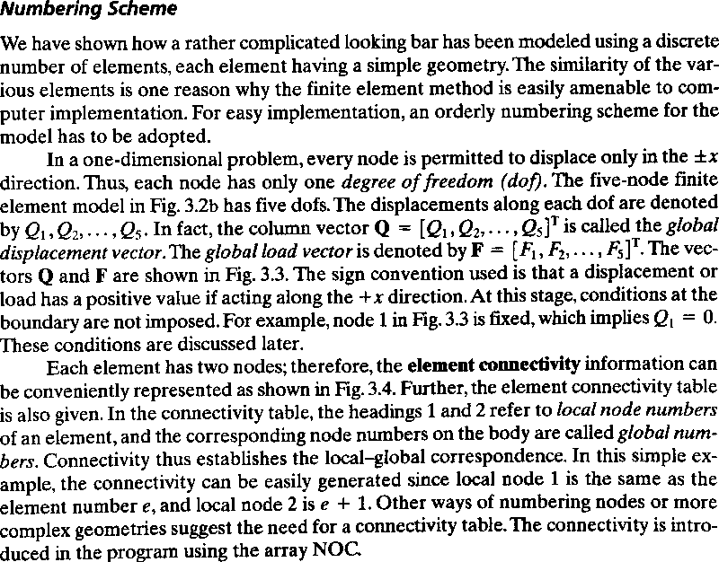

To gain knowledge on assuming interpolation polynomials and deriving the shape functions for some simplex elements

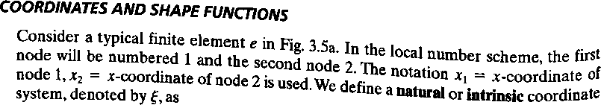

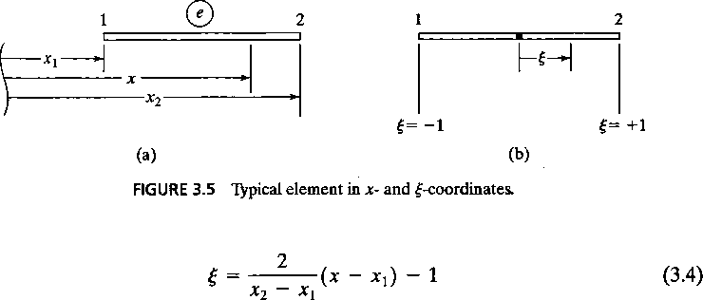
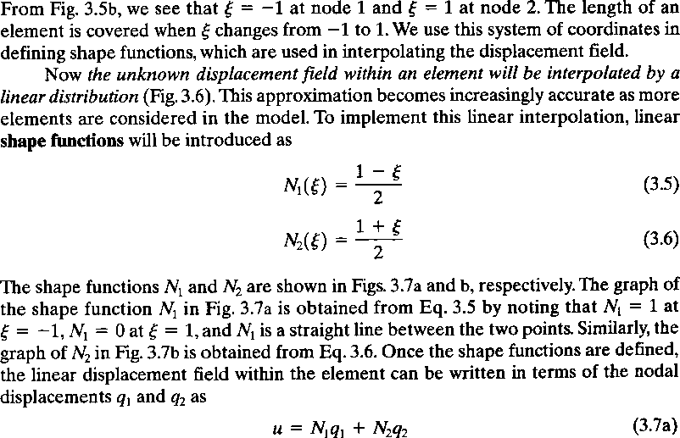

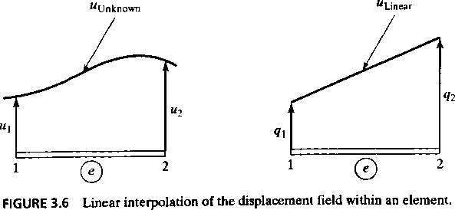

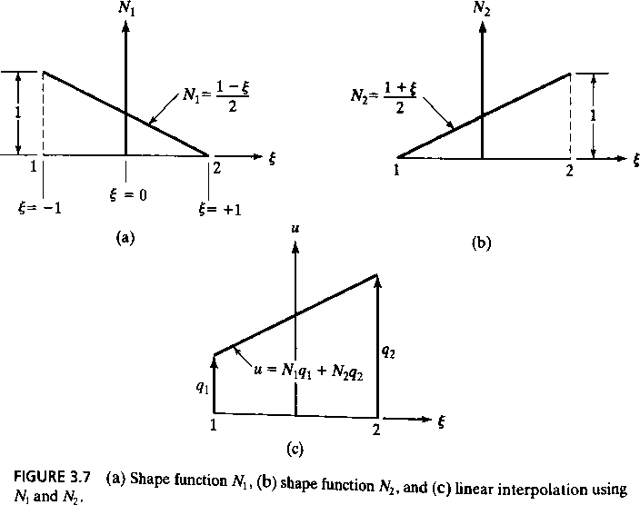
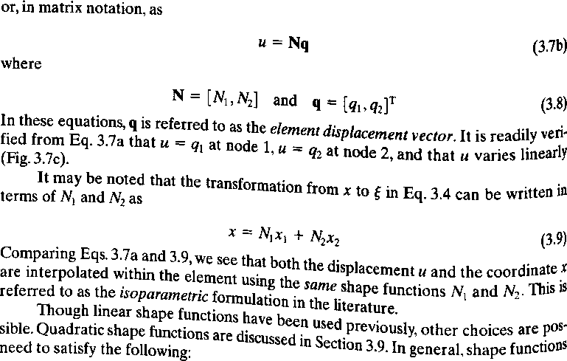

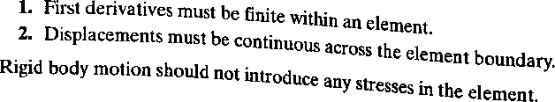

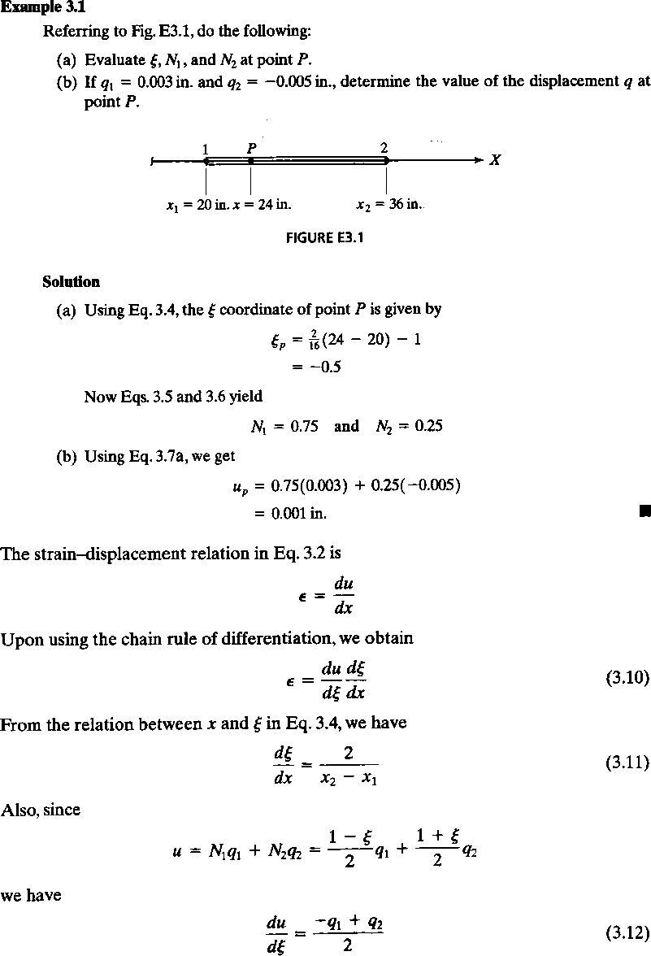

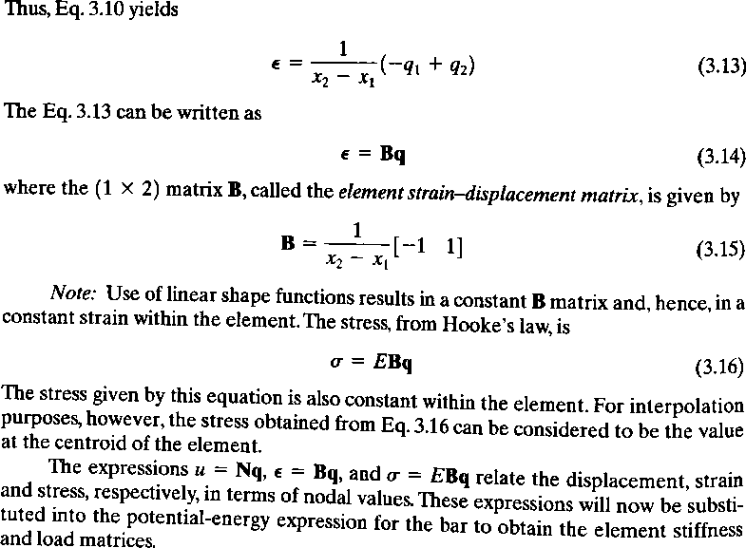

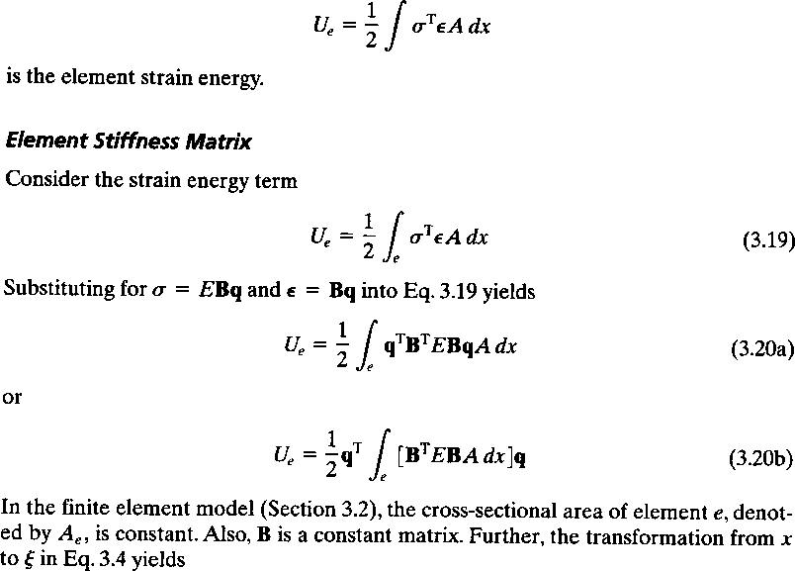

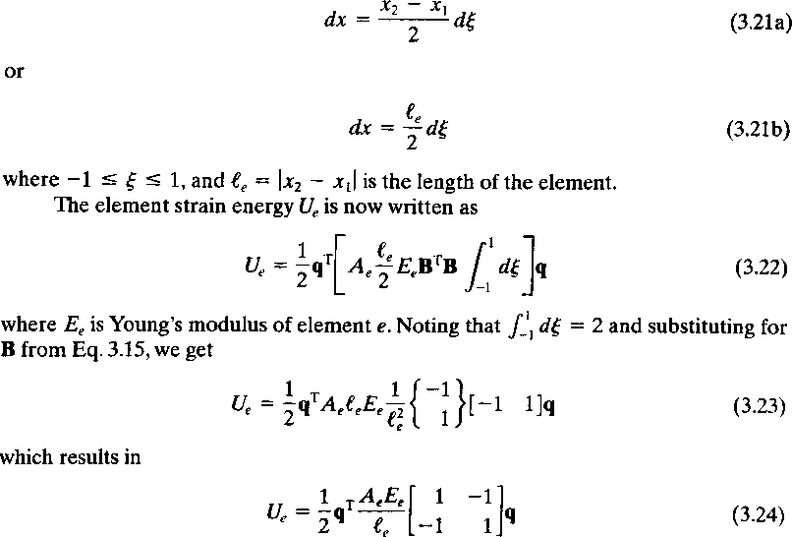

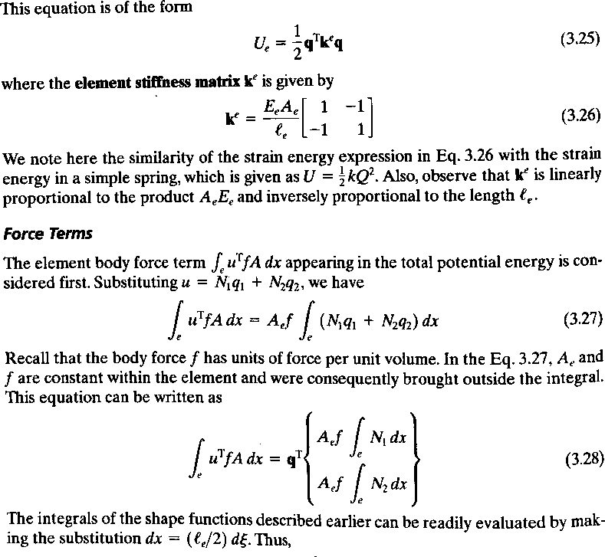

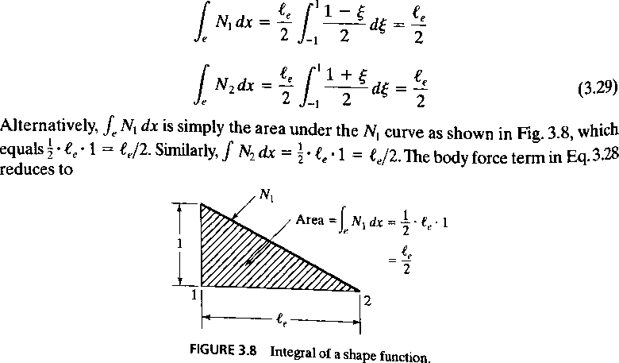

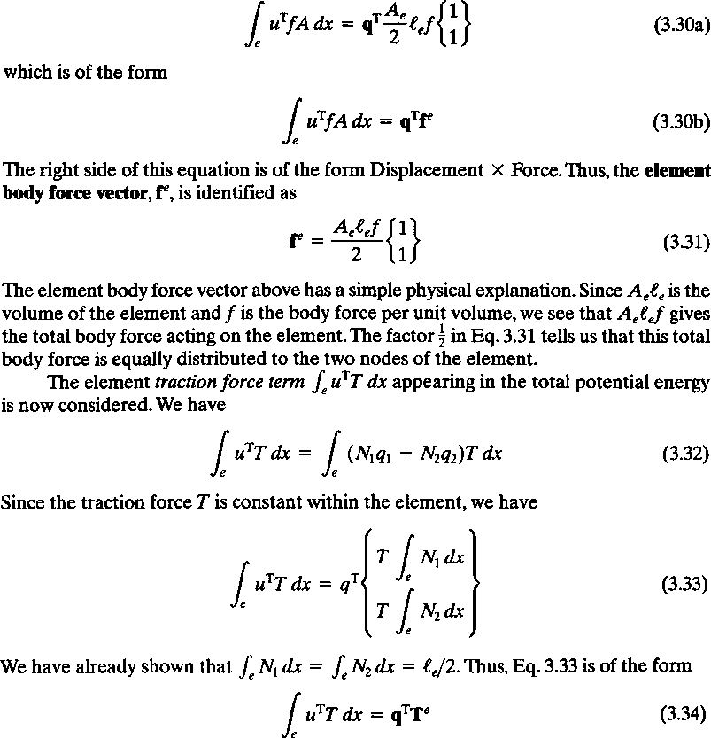

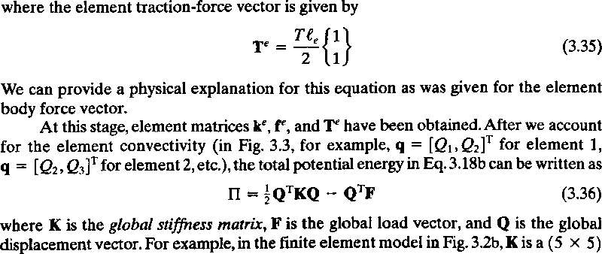

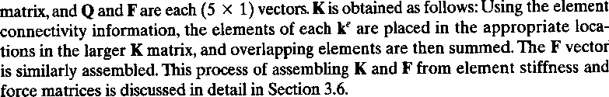
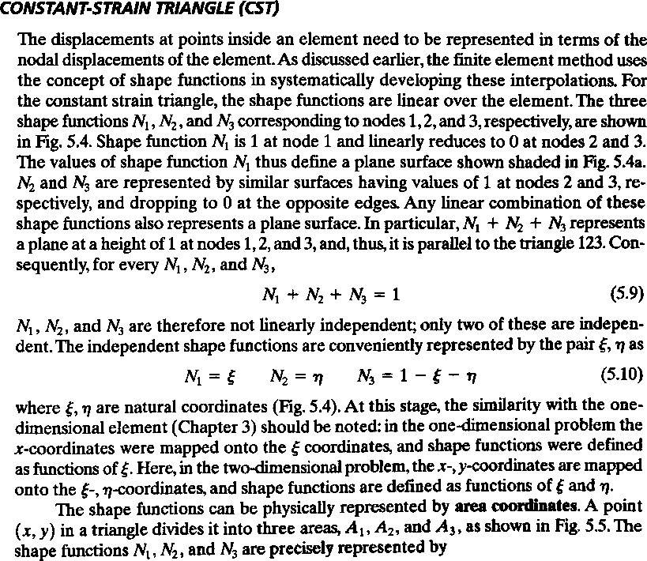
Module-4

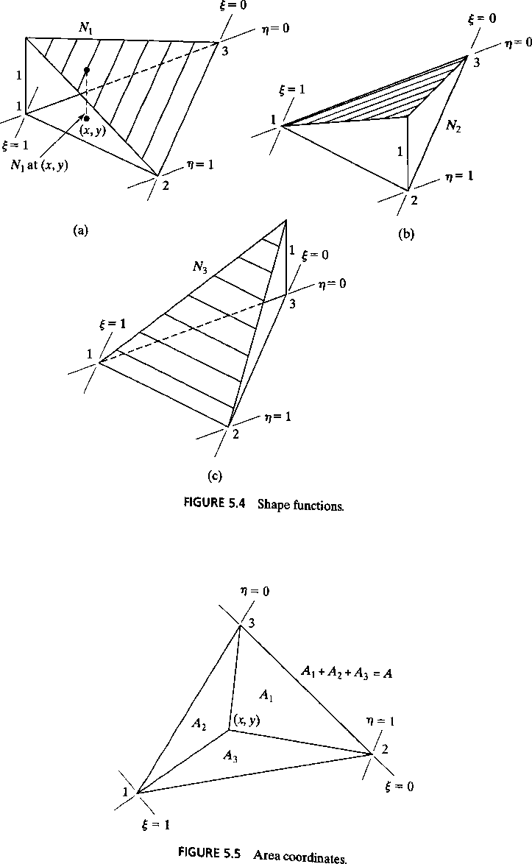

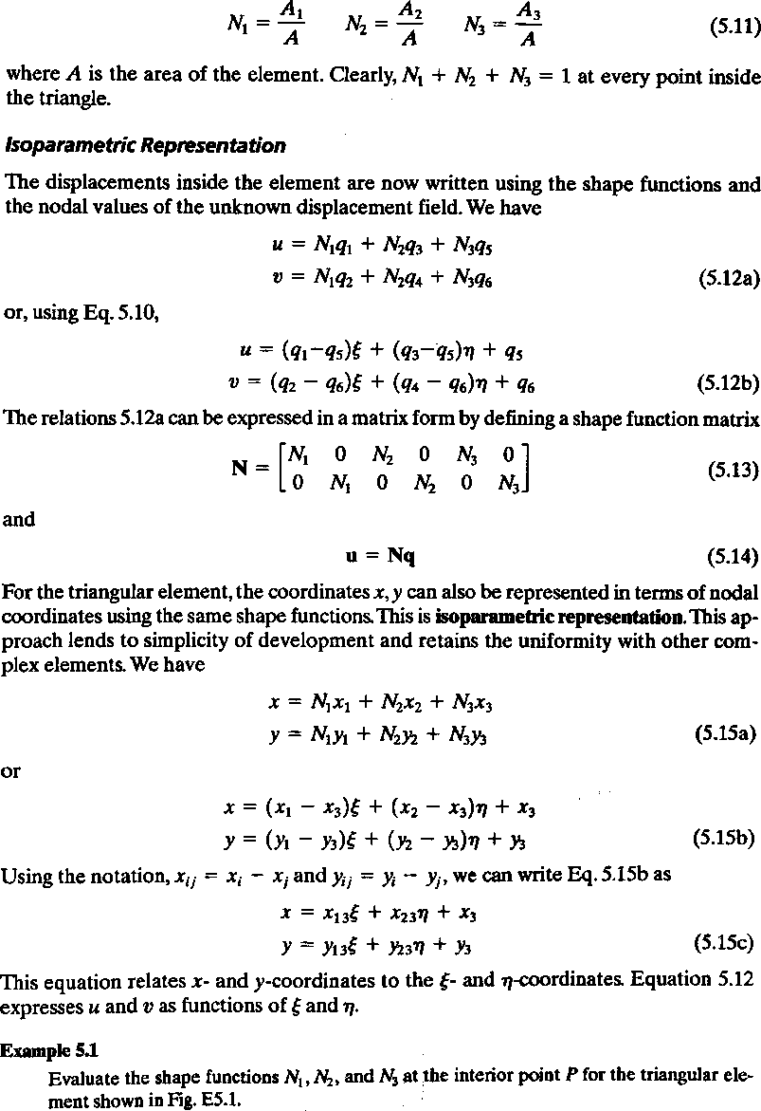

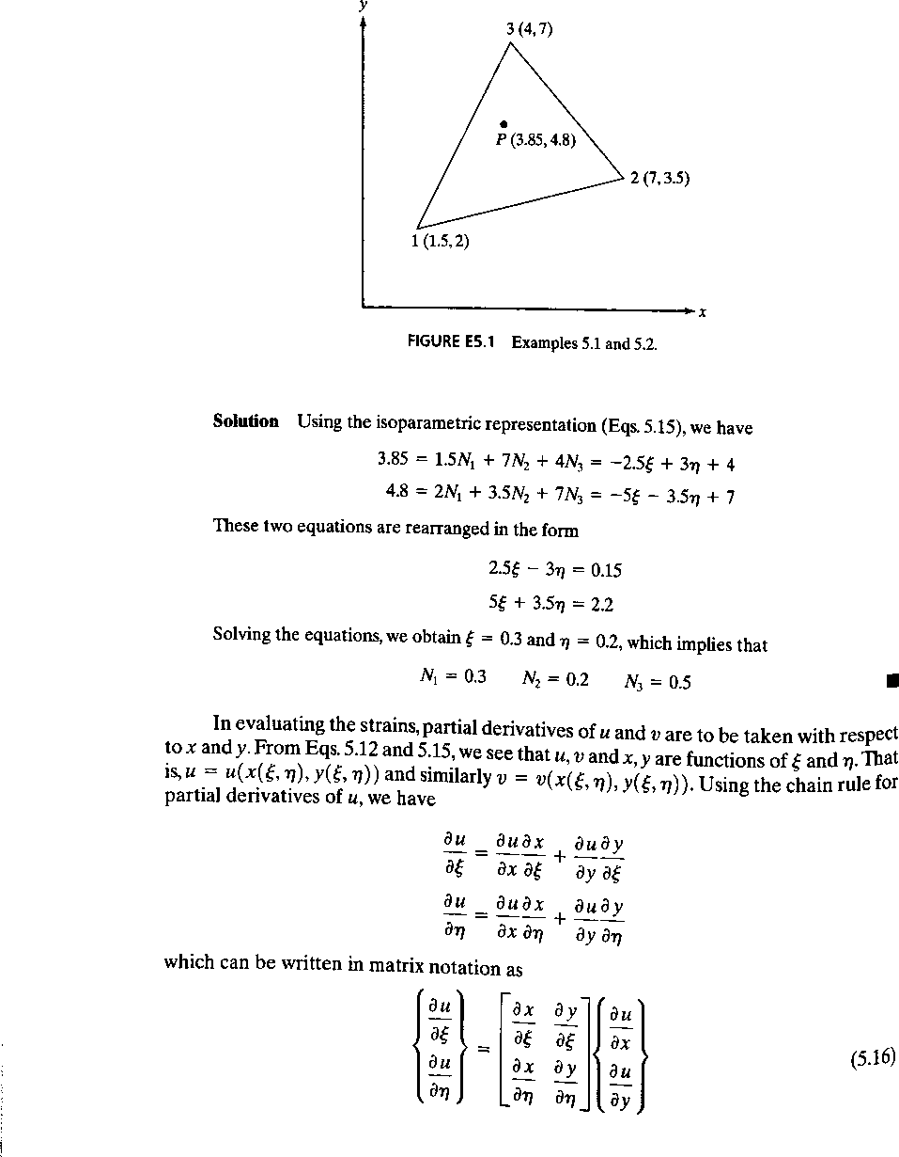

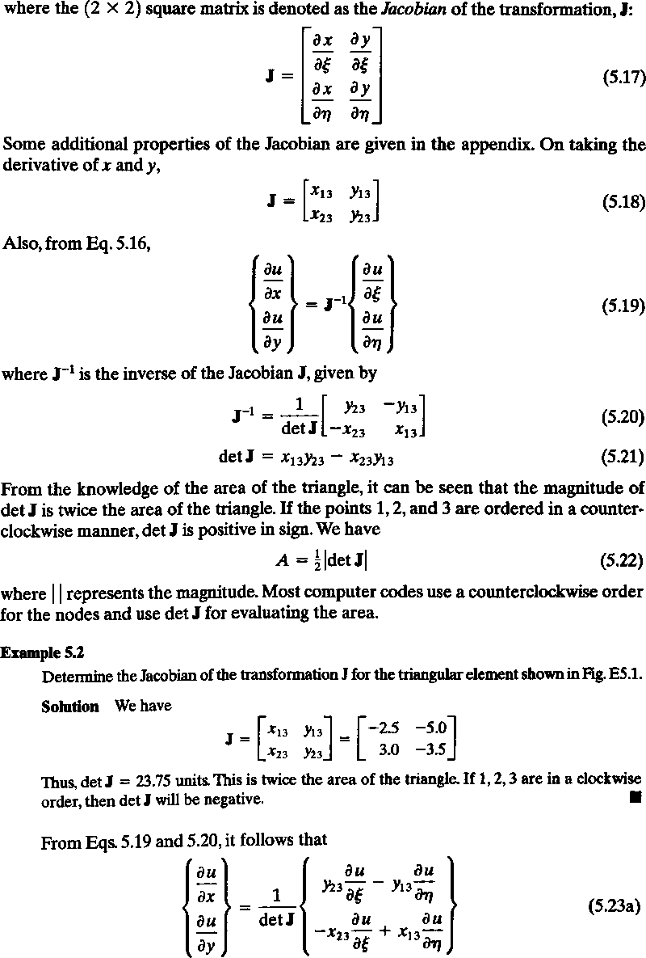

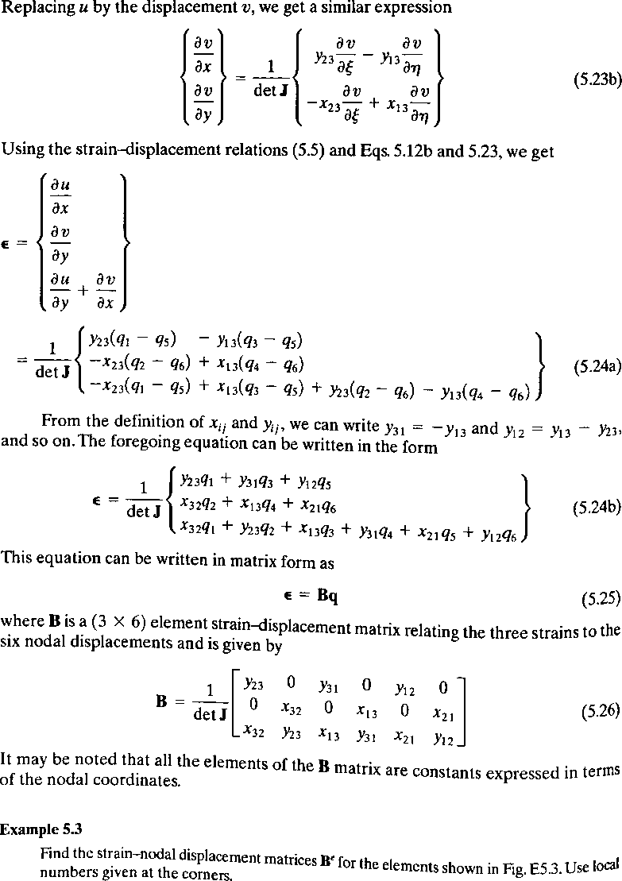

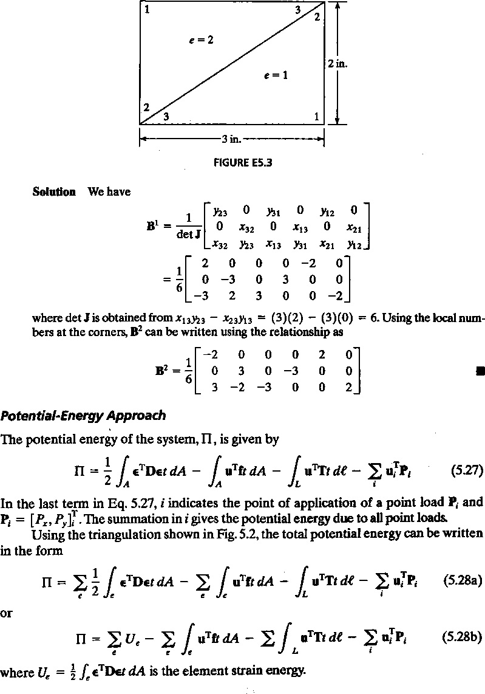

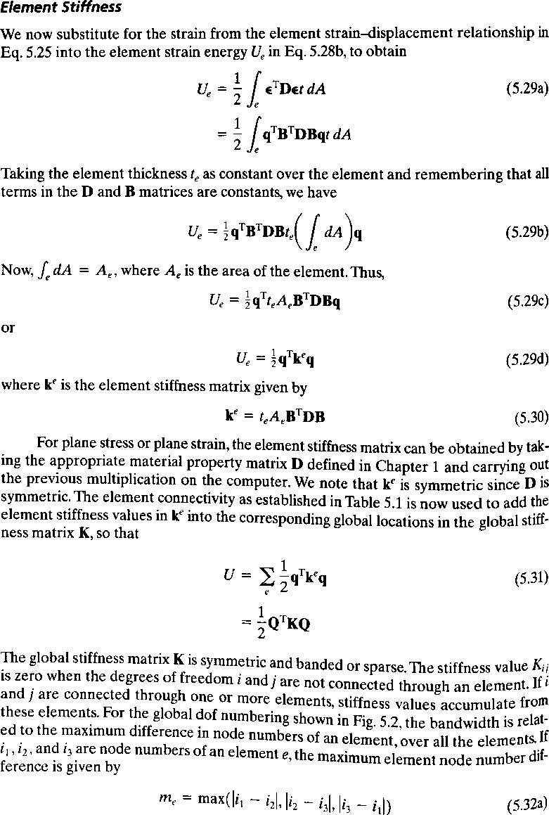

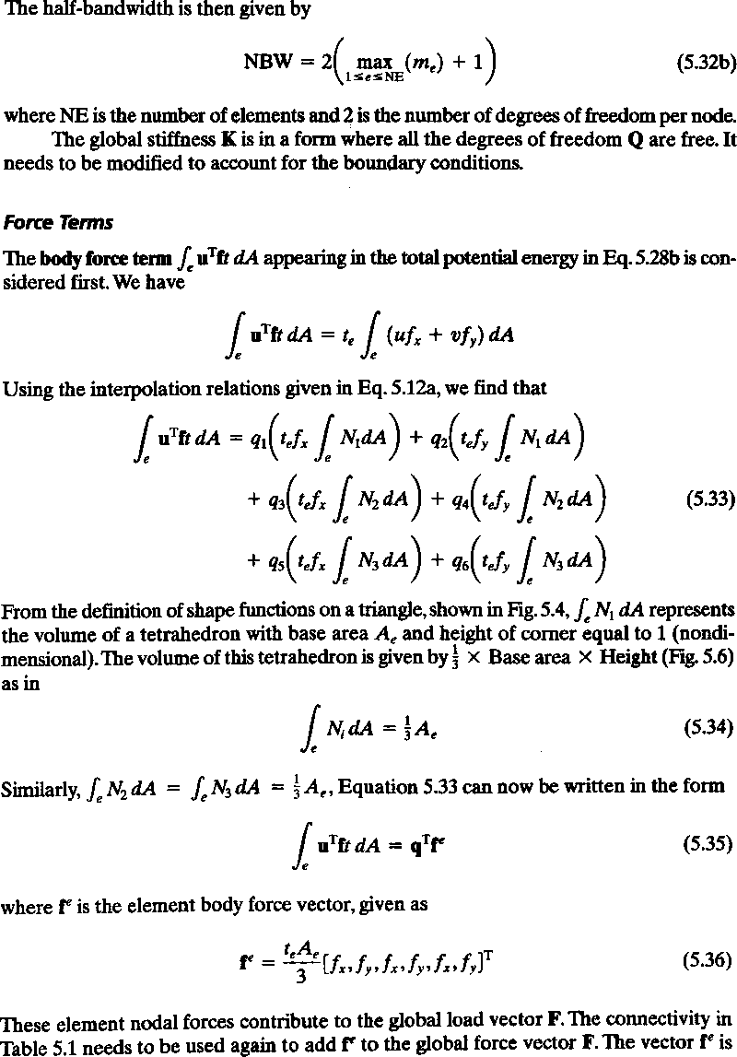

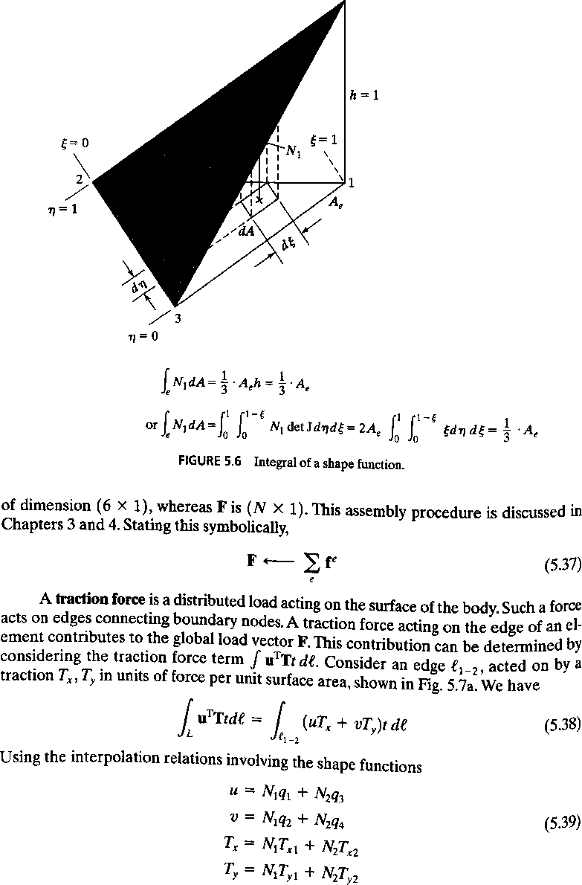

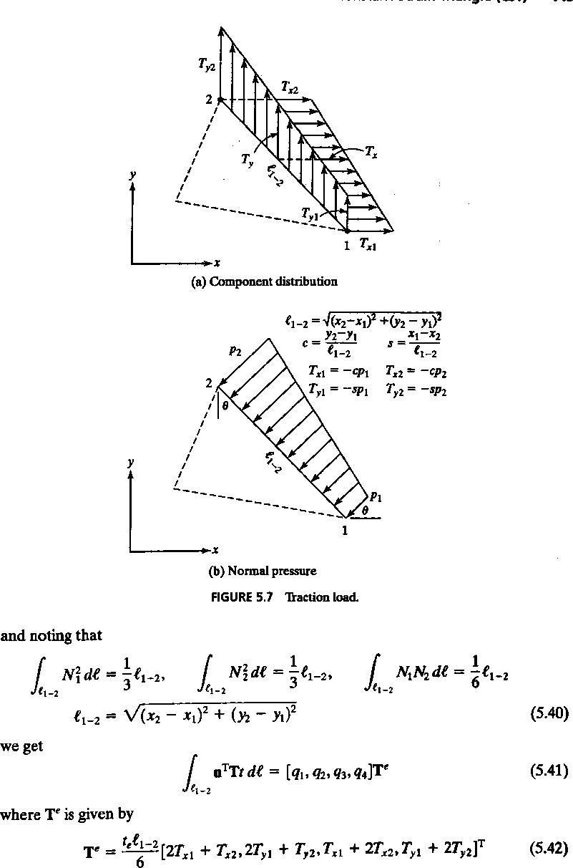

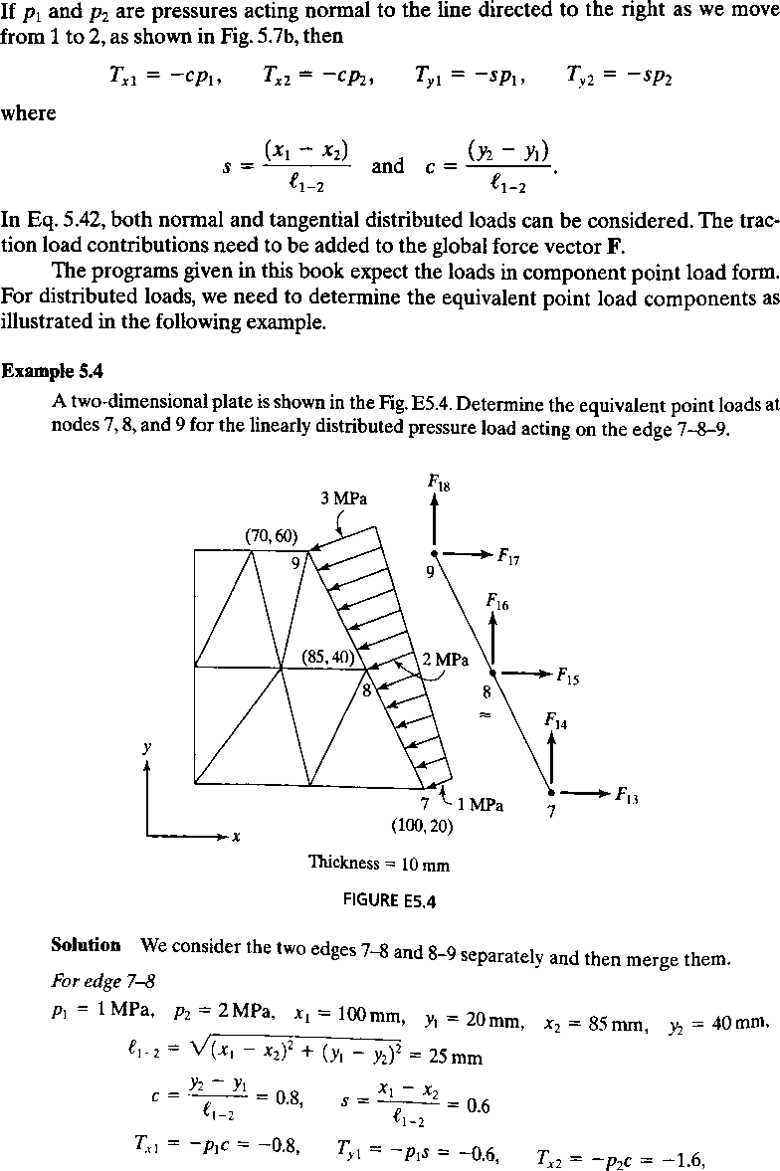

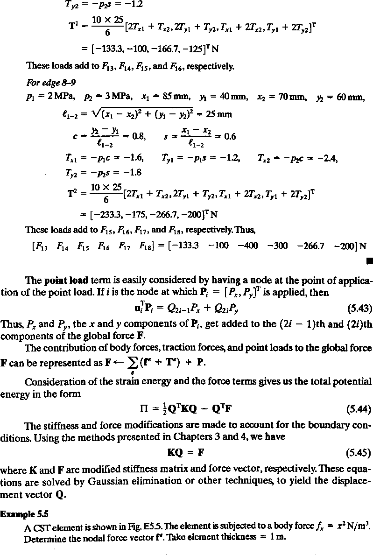

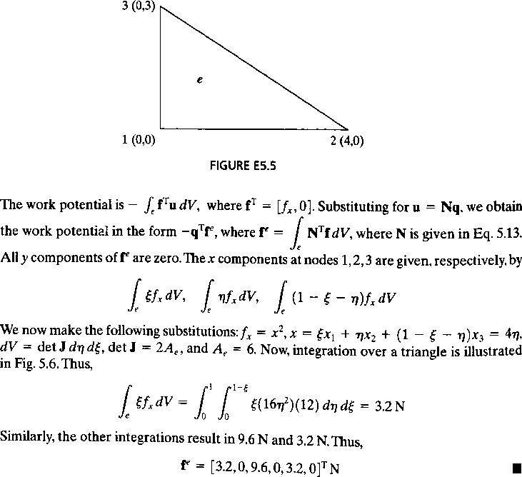

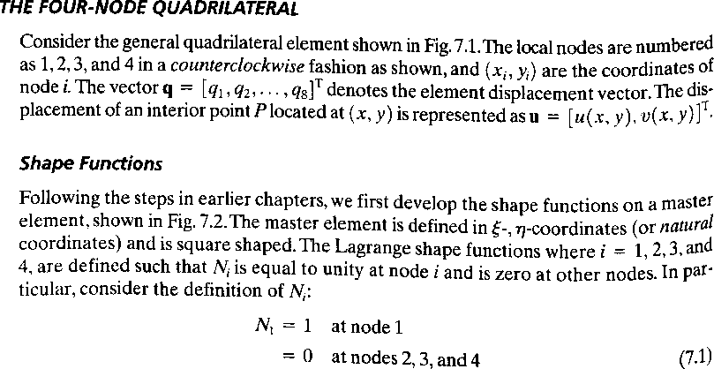

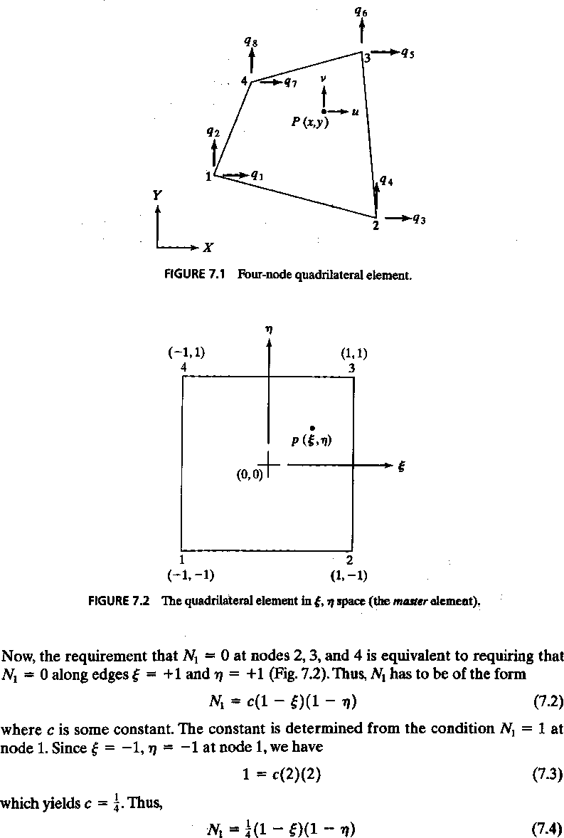

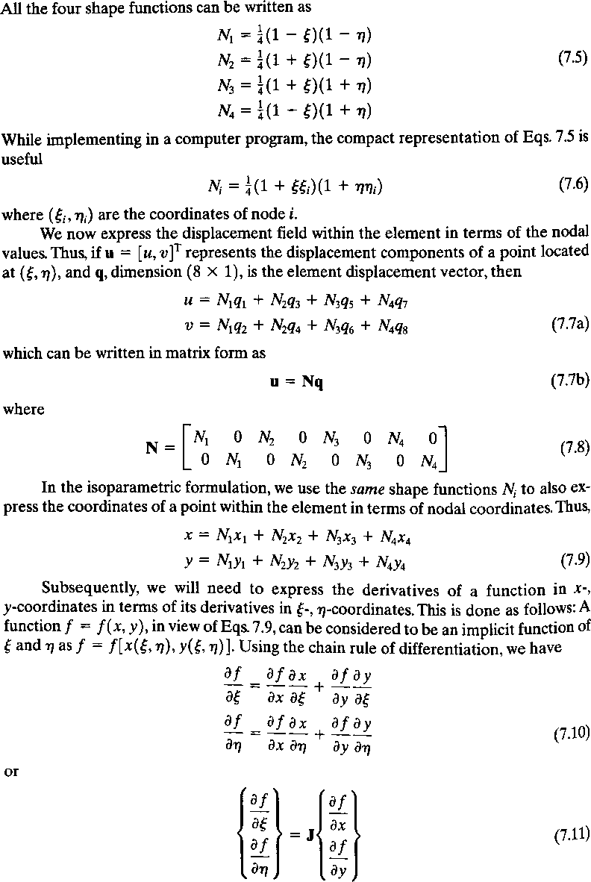

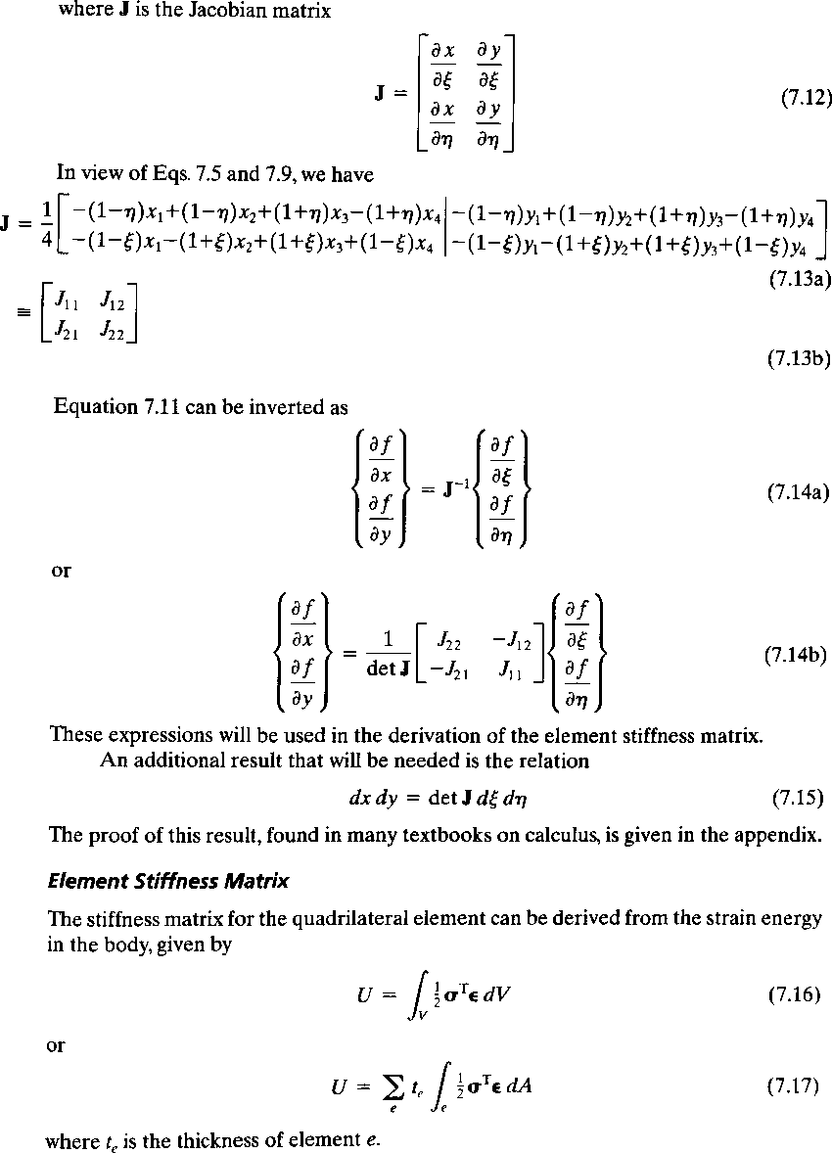

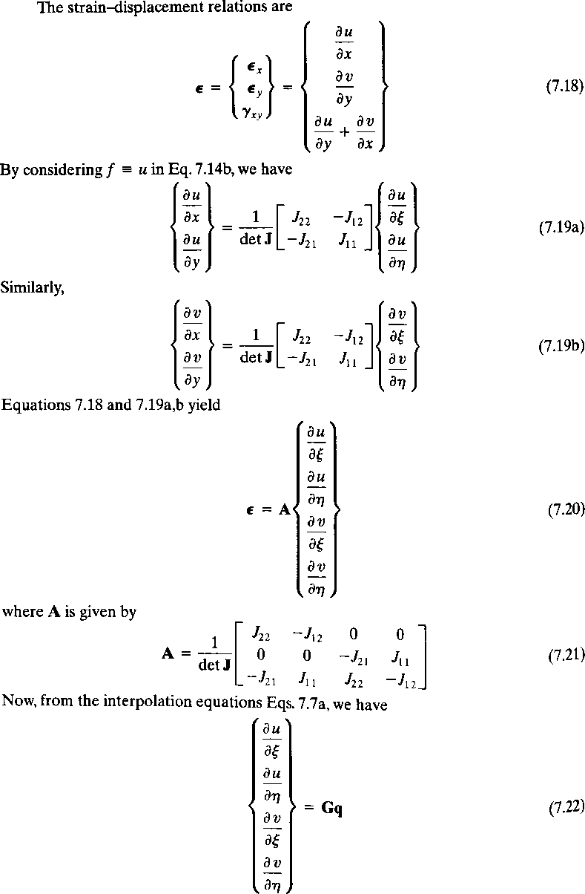

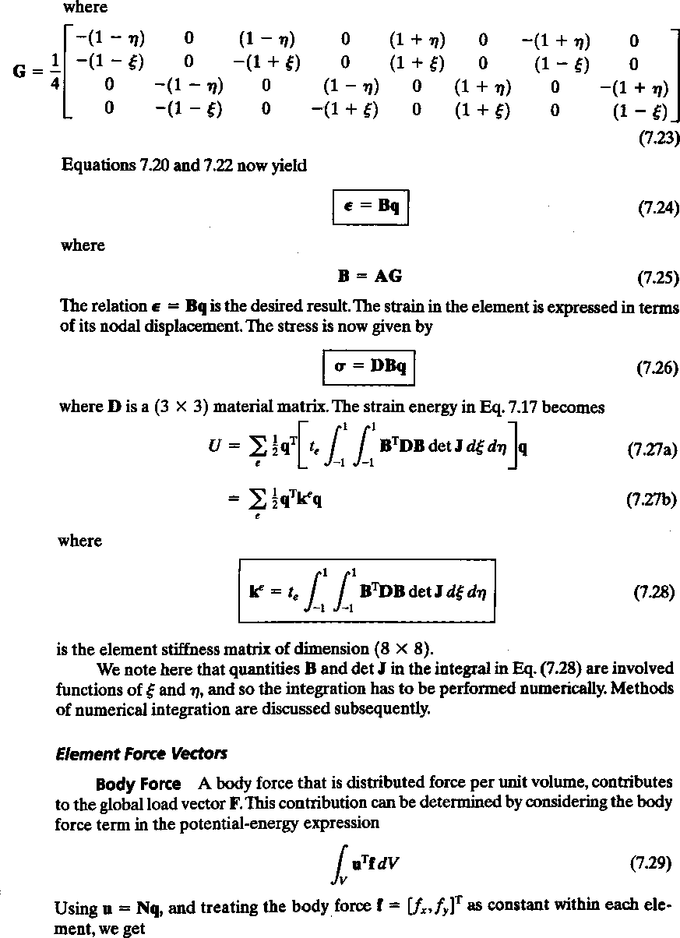

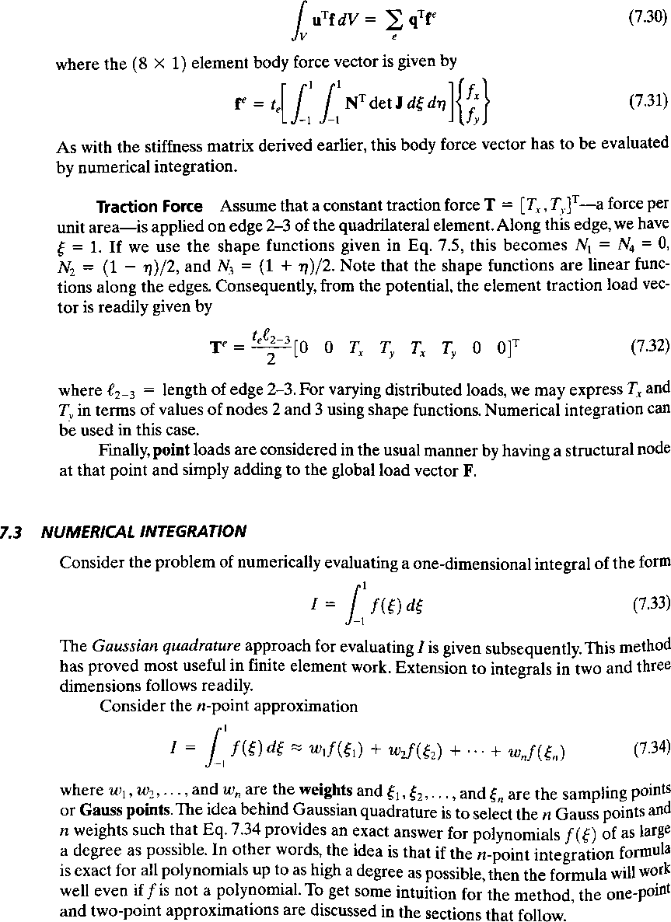

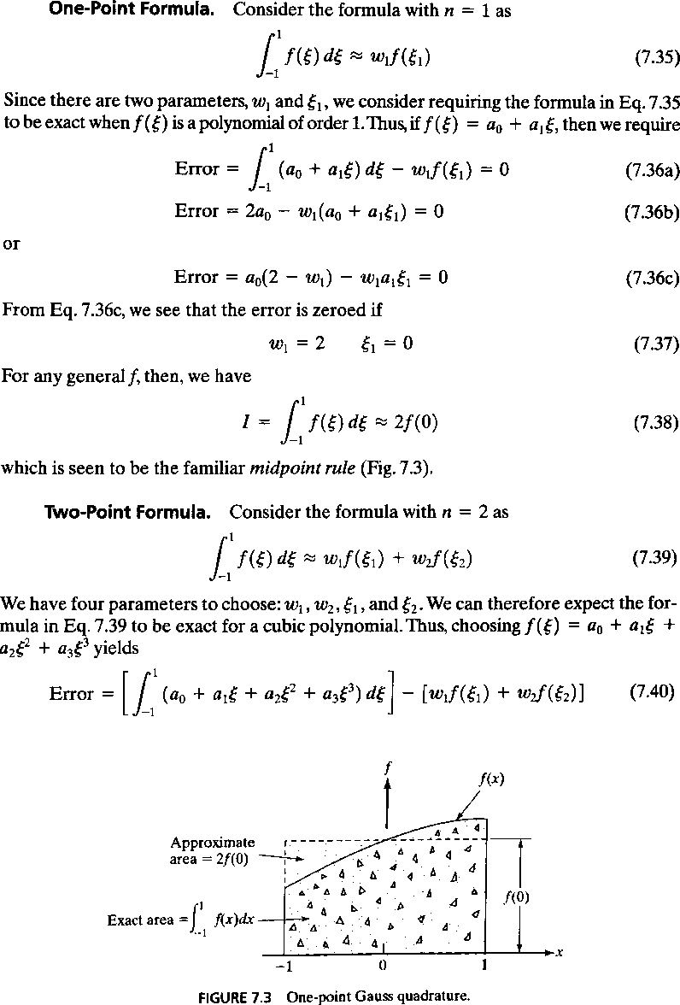

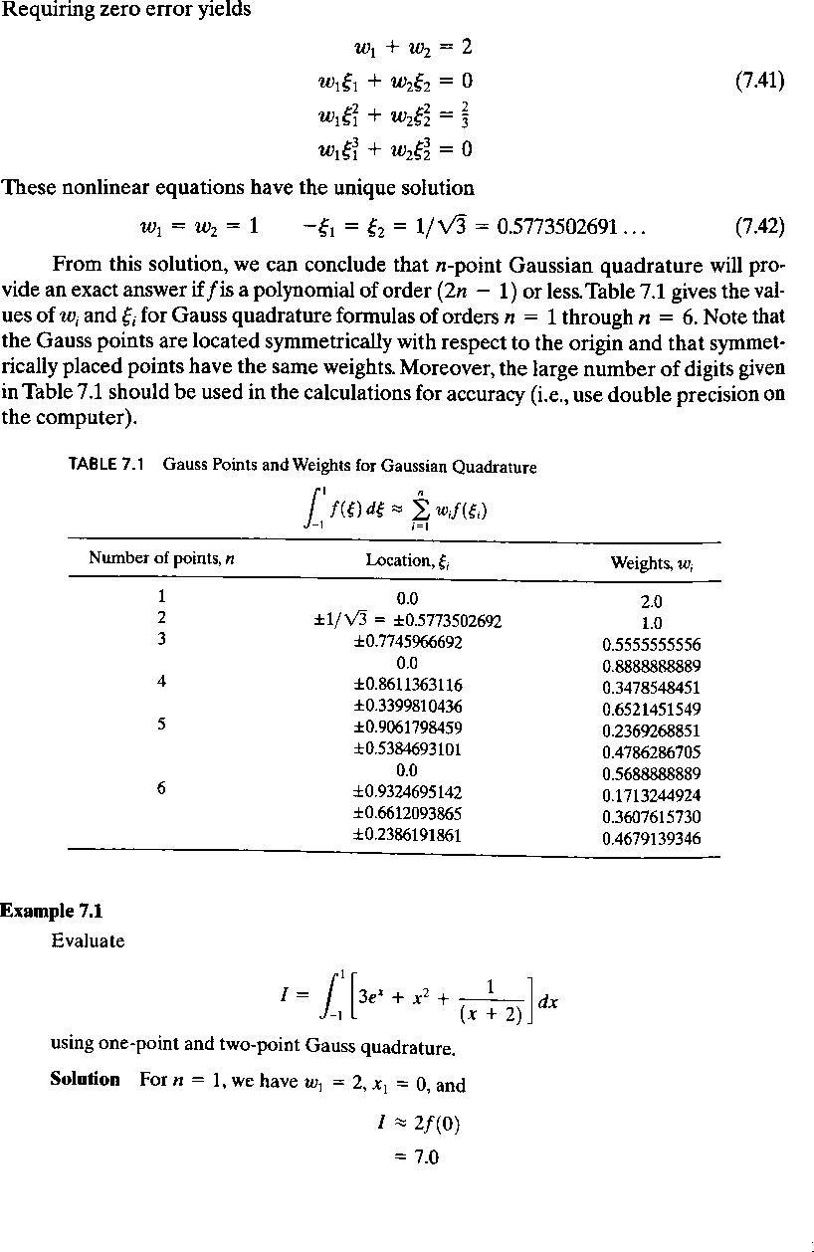

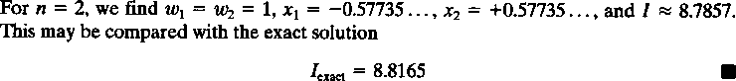

Outcomes
Knowledge on assuming interpolation polynomials and deriving the shape functions for some simplex elements.

Objectives
SOLUTION OF 1-D BAR ELEMENTS

To learn the methods to solve one-dimensional bar elements
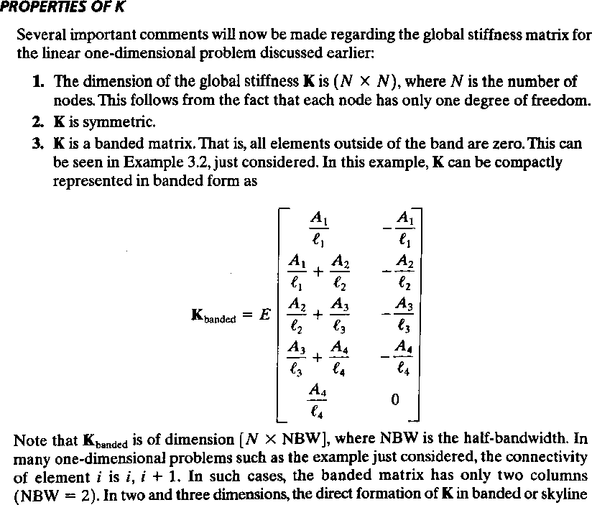

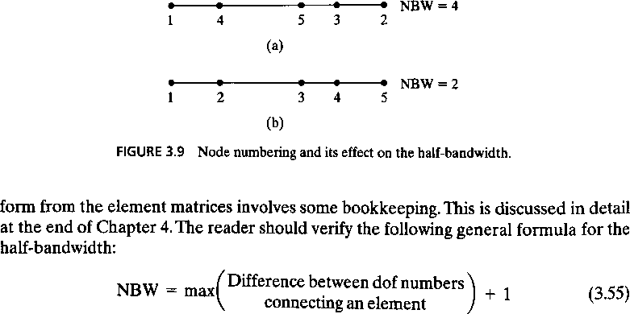

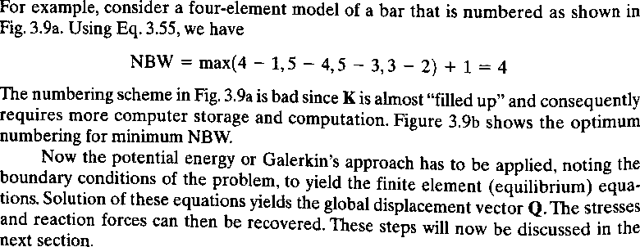

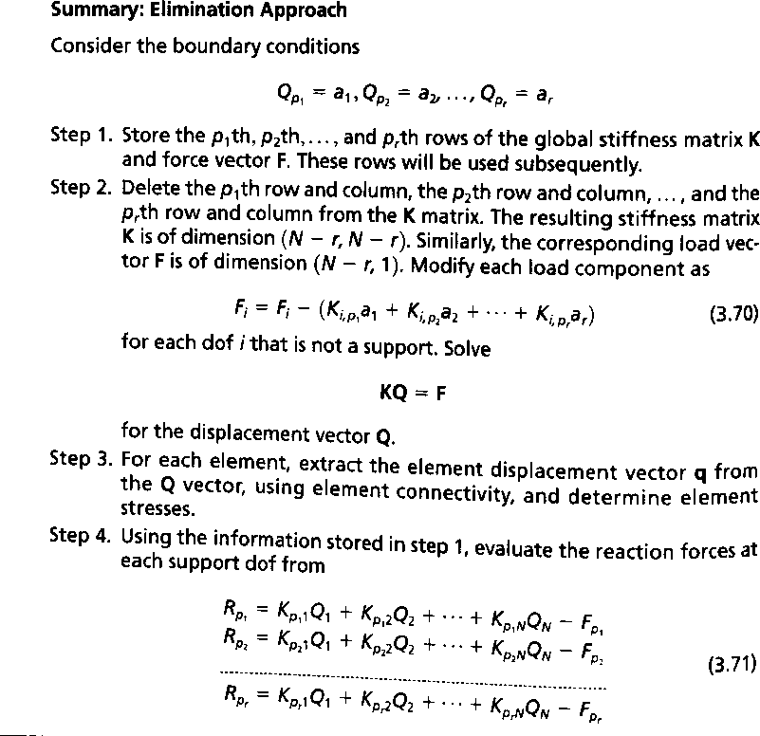
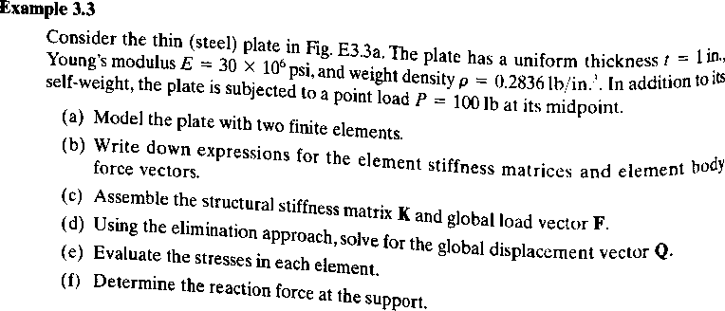

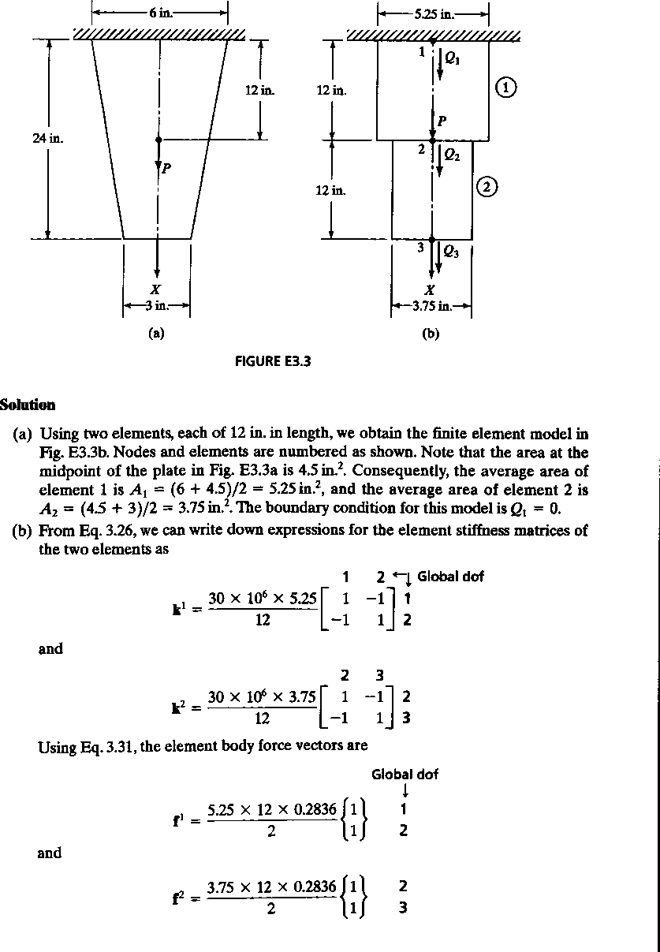

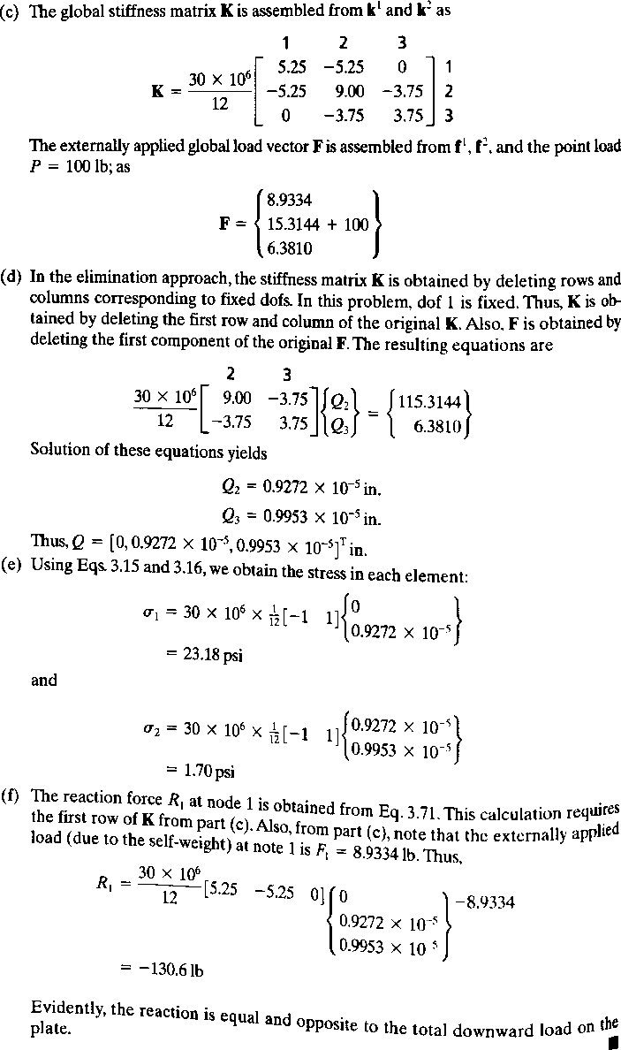

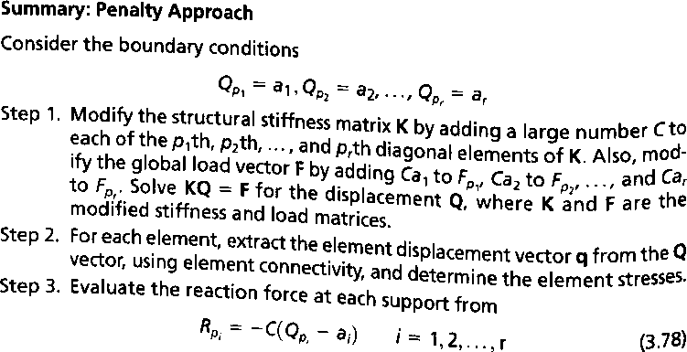

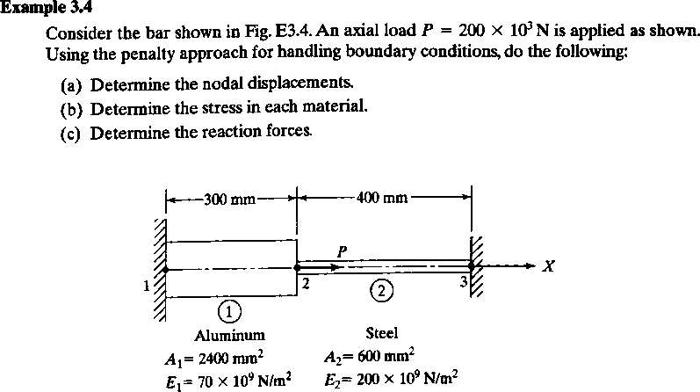

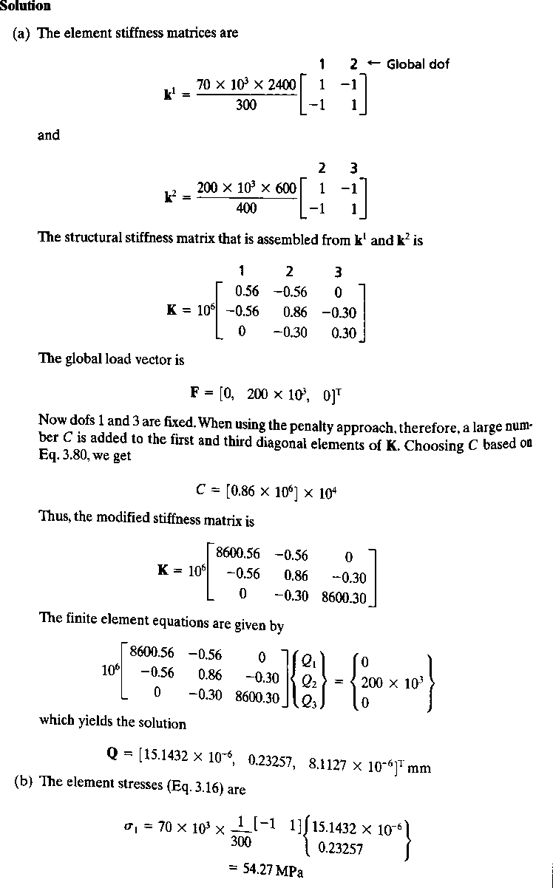

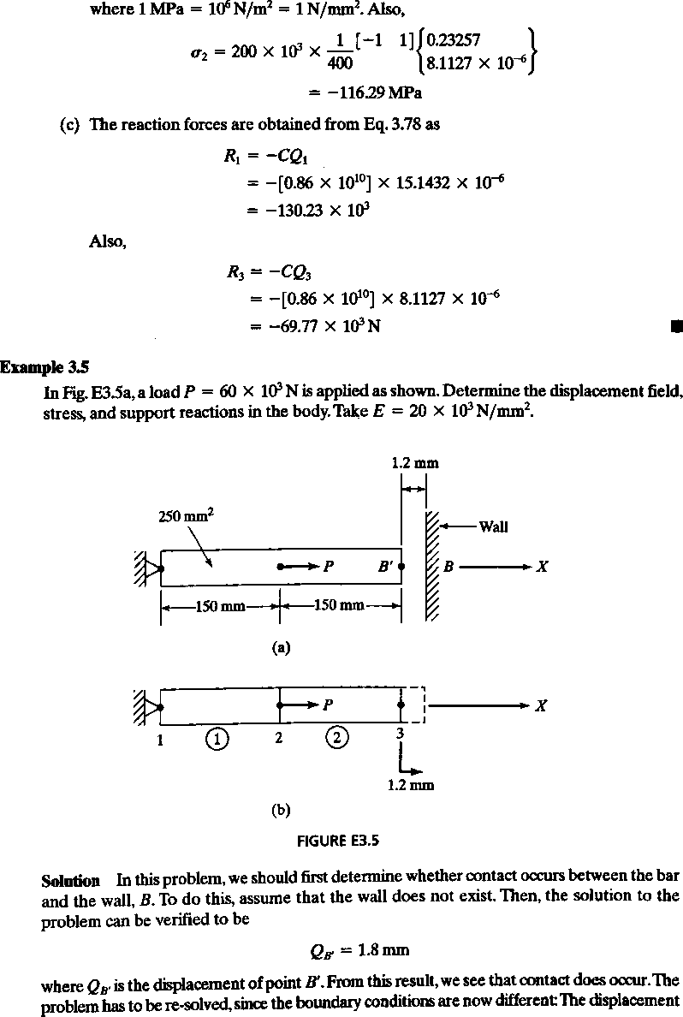

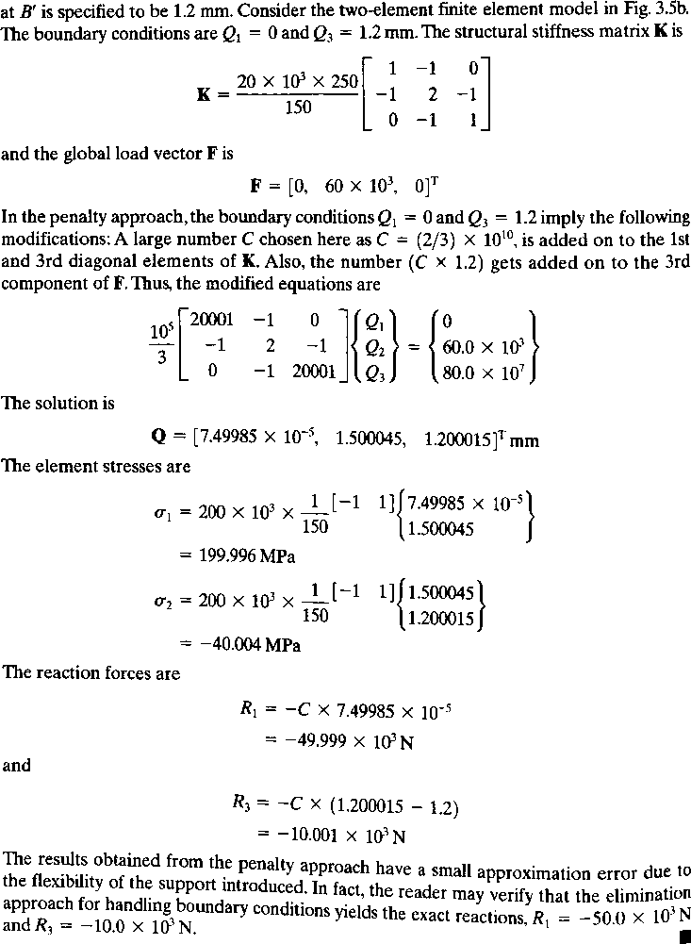

Outcomes
Able to solve one dimensional bar elements problems.

Objectives
TRUSSES

To learn basic knowledge of trusses, deriving shape functions of trusses, solving few problems
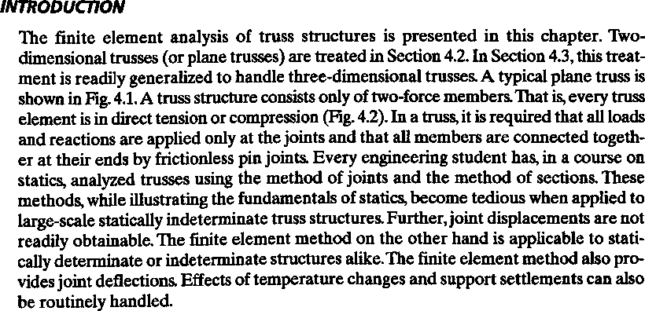
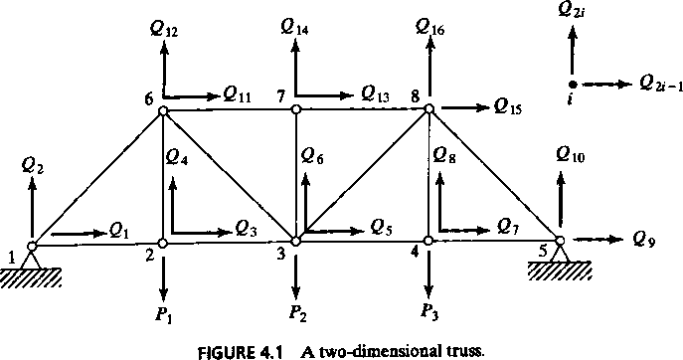

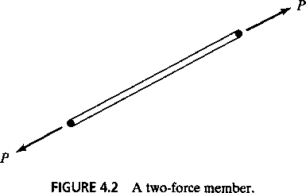

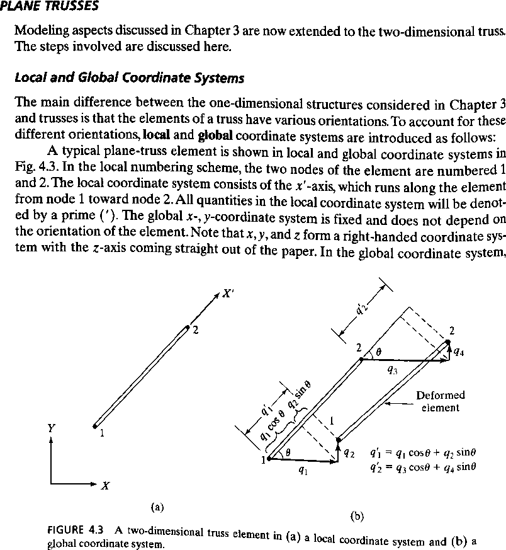

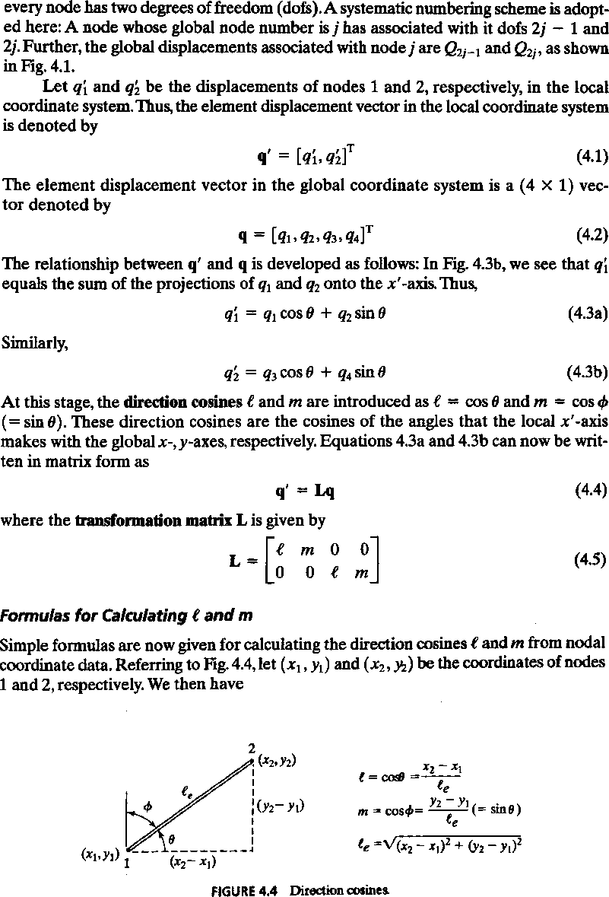

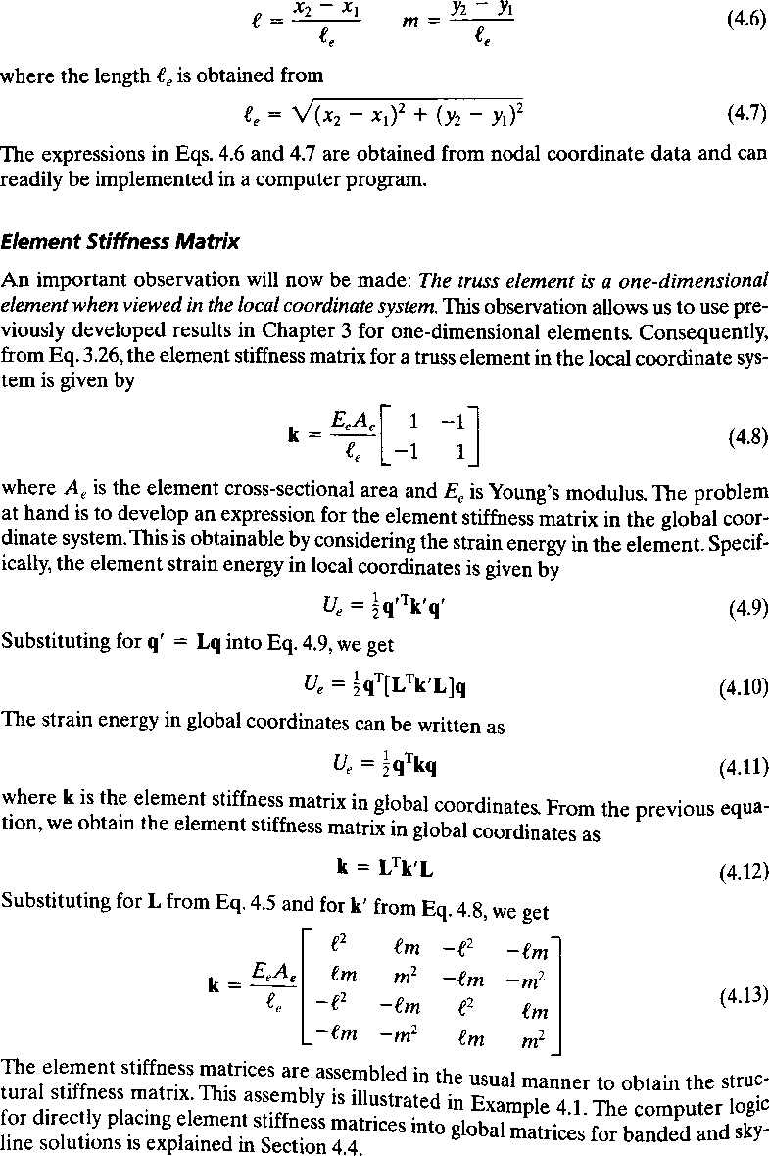

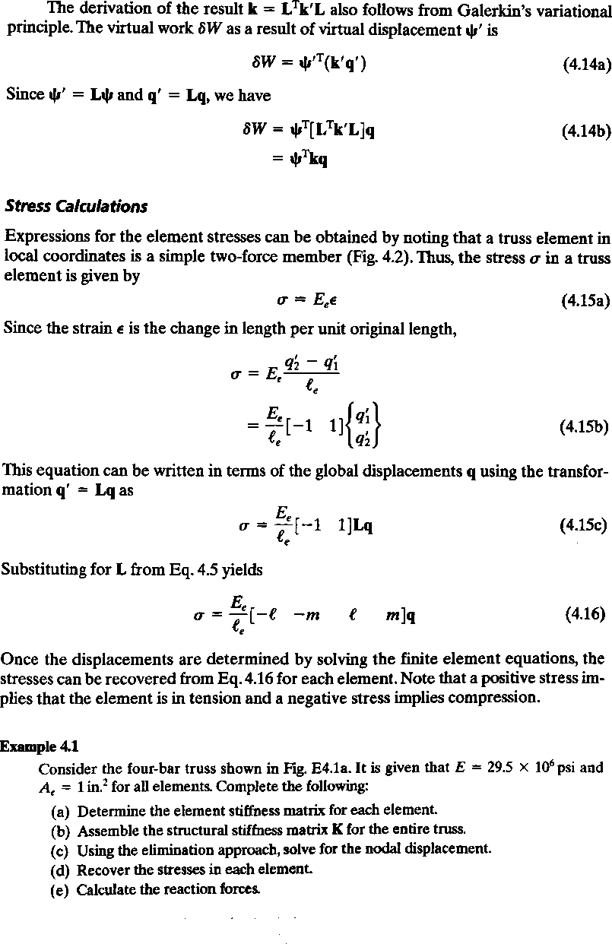

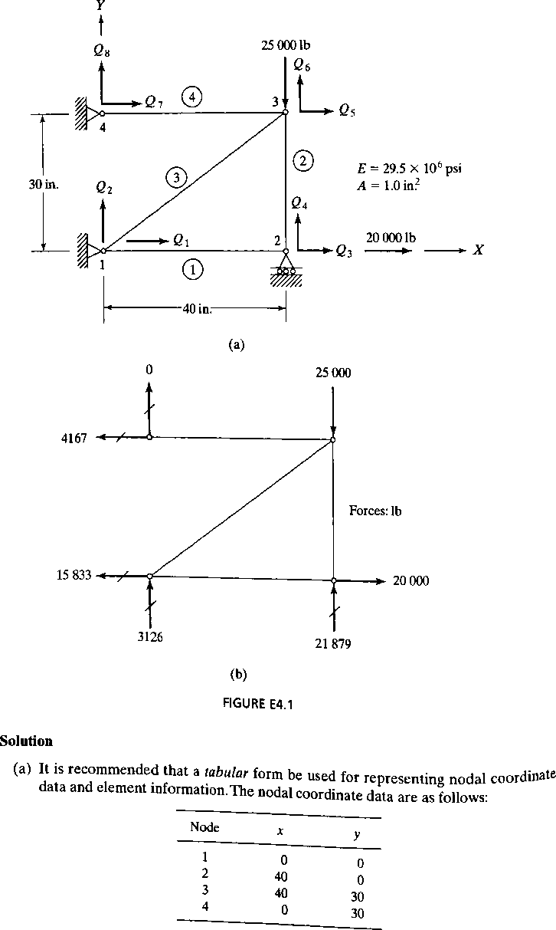

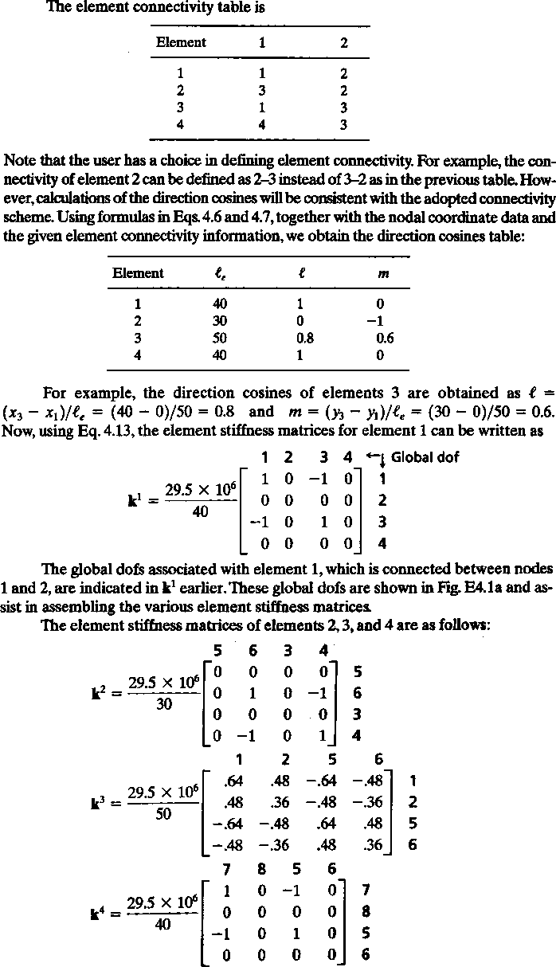

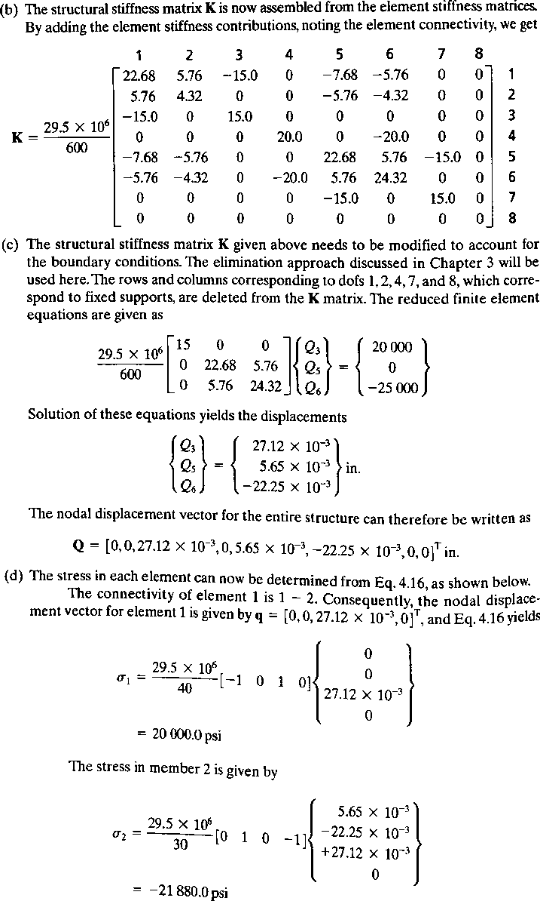

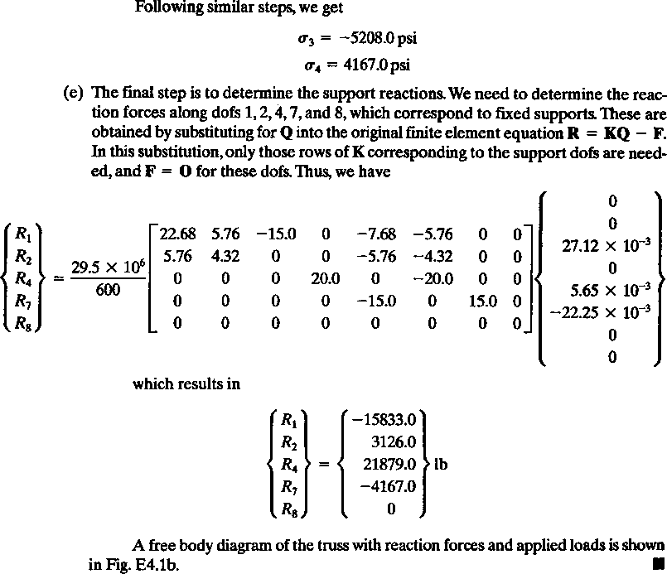

Outcomes
Able to solve 2-D truss problems using finite element methods

Objectives
BEAMS

To derive the hermite shape functions for beams and solving few problems on beams.
